VS Code Tips

Emmet
To enable the HTML shell command: File | Preferences | Settings. Turn ON the "Trigger Expansion on tab" setting.
- To auto-format your code: <Alt>+<shift>+F
- To create an HTML shell: ! <tab>
- To create filler text: lo<tab>
- To comment/uncomment: <ctrl>/

VS Live Share
Allows you to edit VC files simultaneously with another person:
Click on the Extensions button. Then enter vs live share in the search box. Click on the VS Live Share button:
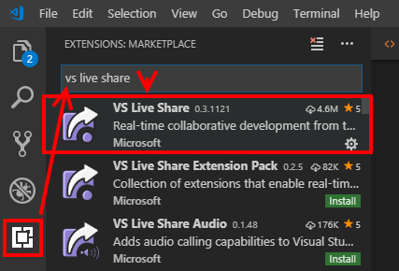
Click on the Install button:
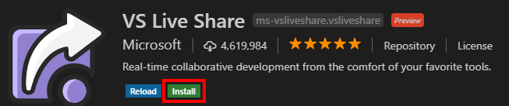

To share your file, click on the Live Code button. Then click on either Join collaboration sessions…, or Start a collaboration session, depending on whether you are starting or joining.
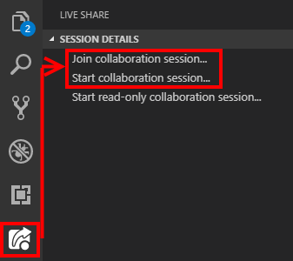

Multiple cursors
To create cursors in multiple locations in your code: <alt> + <click>

Adding opening and closing tags at once
Download and install the HTMLTagwrap extension. To use: (1) select the text, (2) type <alt>+W (for "wrap"). The selected text will be enclosed in <p> tags. Immediately type your new opening tag and both the opening and closing tags will be updated.

Add an "Open in browser" option
Add on the "Open in Browser" by TechER. Extension. When you want to "run" (open in a browser) your HTML file, right-click on it and select Open in Default Browser.

