jQuery #1

Output:
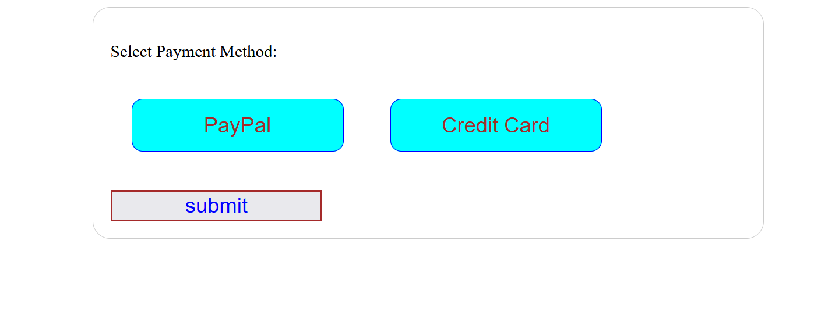

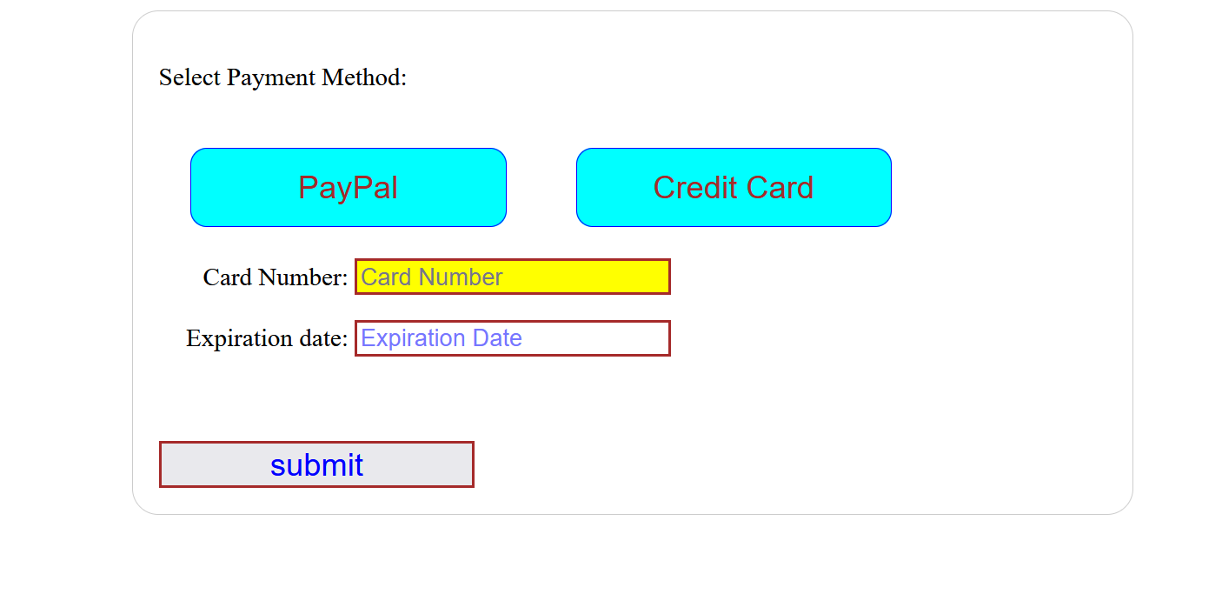

HTML:
Create an HTML file and create a <form> element in the body. All of our HTML will go in the <form> element. Add two buttons (<button>), labeled Pay Pal and Credit Card. Below the buttons should be two <input> text boxes, each with an associated <label> to its left. The label for the first input box should be Card Number. The label for the second input box should be Expiration Date. The placeholder text for the first input box should be Card Number. The placeholder text for the second input box should be Expiration Date. Add a Submit button at the bottom. Check out the for attribute for the label element, and the type attribute for the button and input elements. Add any classes and IDs that will make your CSS and jQuery easier to implement.

CSS:
Apply the following formatting to the buttons:
- Set their background color to a color other than white.
- Set their text color to a dark color. Your color must contrast with the background color.
- Set their border color to a dark color.
- Make the buttons the same width and height.
- Round the corners.
- Set the font to a sans-serif font.
- Set the font size.
- The cursor should change into a hand/pointer when the mouse passes over the buttons.
- Add spacing if necessary to separate the buttons.
Apply the following formatting to the input boxes:
- Dark solid border.
- Width: 200 pixels.
- Text color: a dark color.

jQuery:
Useful things to know: mouse events, this, the css jQuery method, hide, show, toggle, focus, blur.
When your HTML document is loaded, hide the following [1 pt]:
- The credit card input label.
- The credit card input box.
- The expiration date input label.
- The expiration date box.

The mouse
When the mouse moves over a button [2]:
- Change the button's background color, but only change the background color for the button the mouse is currently hovering over. Do not change the background color for the other button.
When the mouse moves off a button [2]:
- Change the button's background color back to the original background color.
When the mouse clicks down on a button [2]:
- Change the button's color to something other than the two other colors you are already using for the button.
When the mouse release button is released while on a button [2]:
- Change the button's color back to its original color.

The PayPal button
When the user clicks on the PayPal button, go to the www.paypal.com site [2]. Check out the window.open JavaScript method.

The Credit Card button
When the user clicks on the Credit Card button, do the following (this is "toggling" the visible state of the element—check out the show(), hide(), and toggle() functions in jQuery) [4]:
- If the credit card number input box, its label, the expiration date input box, and its label are currently hidden, show them. If they are currently visible, hide them.
When the user clicks on the "Credit Card" button [2]:
- Set the focus to the credit card number input box.
When either one of the input boxes receives the focus [2]:
- Set its background color to a shade of yellow.
When either one of the input boxes loses the focus [2]:
- Set its background color back to white.
Put all CSS, JavaScript/jQuery code in your HTML file and submit the HTML file to the drop box. Do not zip.

