CSS Homework #3
Create a BCU "home page" that looks like this: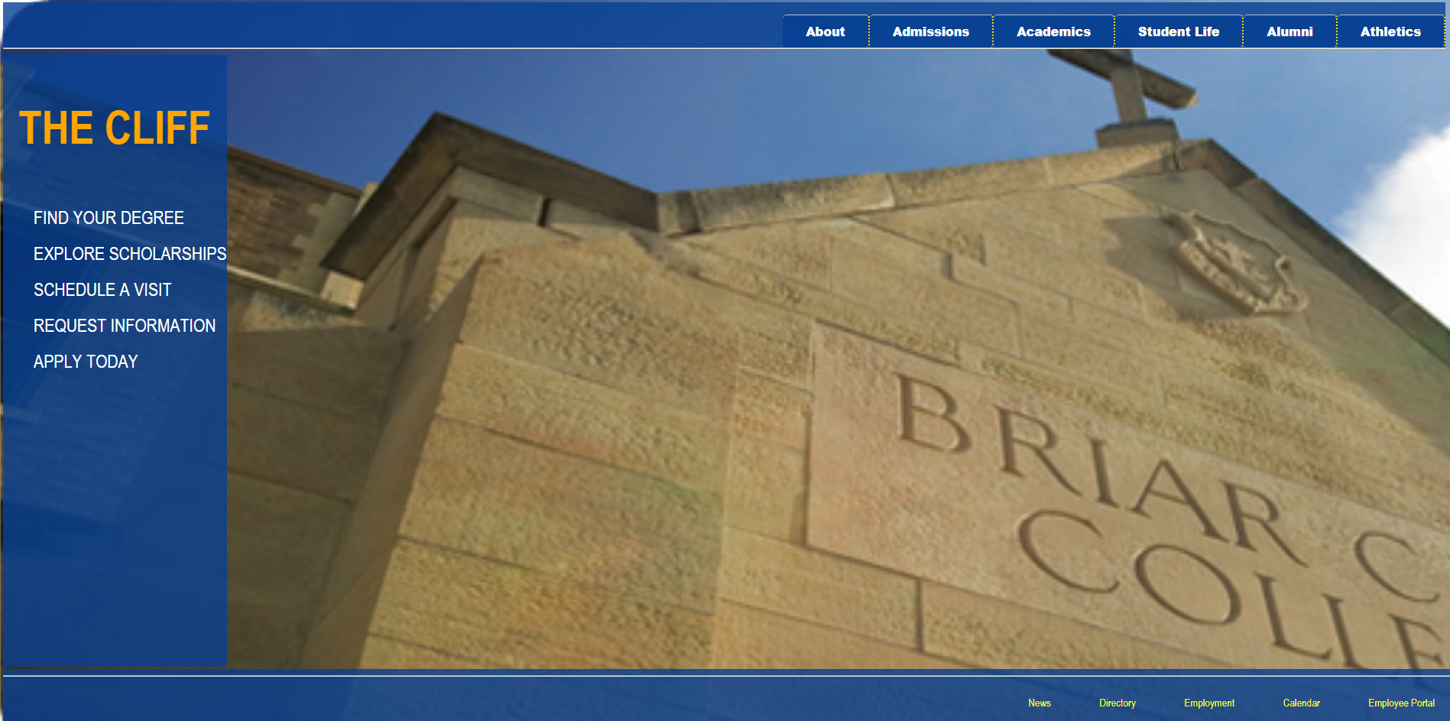

50 points. Create the HTML yourself. Put your CSS in a separate file and link to it. Add your name as a comment in the head. Feel free to use any appropriate tags, classes, and IDs that will make it easier to implement the CSS. Zip your HTML and CSS files and submit the zipped file.
Use the background picture of BCU available on our class website and link to html file.
Write the code for creating header links (About, Admissions…), sidebar (Find Your Degree, Explore Scholarships…) and footer links (News, Directory…) in your html file. All hyperlinks are elements of an unordered list. All hyperlinks can link to www.example.com or just #. Use <header> tags for the header, <nav> tags for the sidebar, and <footer> tags for the footer. There will be four classes (general, header, sidebar, footer). Use comments in CSS to identify each class.

General
4 points
- Make Arial Narrow the default font for the entire page. If Arial Narrow isn't available, the browser should use the default sans serif font.
- The BCU picture should be your background picture.
- The BCU picture should not tile but should cover the entire background.
- The background picture should not move when scrolling, hence it should be fixed.

Header (top row):
4 points
- The background color of the top area is a shade of blue. You pick.
- The background color of the top area has its transparency set at 80%.
- The links at the top float to the right of the display. The links must be in the same order as shown above.
- The area at the top always stays at the top when the page is scrolled.

Header links
11 points
- The links are elements of an unordered list.
- The background color of the links is the same as their background, but with their transparency set to 90% to make them appear darker.
- The color of the button text is white.
- The hyperlinks are elements of a list, but they are horizontal.
- The hyperlinks have had their bullets removed.
- The hyperlinks have had their underlines removed.
- The hyperlinks have had padding added to all four sides to make them larger.
- The hyperlinks have centered text.
- The hyperlinks have a dotted gold border on their right side only.
- The hyperlink text gets 20% bigger when a mouse hovers over the button.
- The hyperlinks background color turns to navy blue when a mouse hovers over the button.

Sidebar
18 points
- The background color of the sidebar is the same as the background color of the header.
- The background color of the sidebar has its transparency set at 80%.
- The sidebar is always on the left side of the page.
- The sidebar scrolls when the rest of the page scrolls.

Sidebar Title (THE CLIFF)
- The title is 2.5 times the size of the default text.
- The title text is bold/heavy.
- The title text color is orange.
- The title text is centered in the sidebar.

Sidebar hyperlinks
- The links are elements of an unordered list.
- The hyperlinks have had their bullets removed.
- The hyperlinks have had their underlines removed.
- The group of hyperlinks has a height of 1000 pixels. This should make it tall enough so scroll.
- The group of hyperlinks is always on the left side of the page.
- The group hyperlinks background is the same blue as the background of the top buttons.
- The hyperlink text is 1.5 times the size of the default text.
- The hyperlink text is white.
- The hyperlinks are padded with 10 pixels on all four sides to make them larger.
- The hyperlinks change their background color to orange when a mouse hovers over them.

Footer
13 points
- The links are elements of an unordered list.
- The hyperlinks have had their bullets removed.
- The hyperlinks have had their underlines removed.
- The hyperlinks are elements of a list, but they are horizontal.
- The background color of the footer is the same as for the sidebar and header.
- The background color transparency is also 80%.
- The footer will stay at the bottom of the screen when scrolling takes place.
- The footer takes up the entire width of the page.
- The links in the footer will stay on the right side of the footer and must be in the same order as the picture above.
- The link text is 90% the size of the default text.
- The link text color is yellow.
- The links have been padded on all four sides to make them larger.
- When the mouse hovers over a link, an underline is added to the text.

