CSS Reference

Link to a style sheet
<link rel="stylesheet" href="mystyle.css">

Relative Lengths
CSS has absolute lengths, but it is best to avoid them. Relative length units specify a length relative to another length property. Relative length units scale better between different rendering medium.
- Unit | - Example | - Description
em | 1.5em | Relative to the font-size of the element (2em means 2 times the size of the current font)
rem | 1.5rem | Relative to font-size of the root element
vw | 5vw | Relative to 1% of the width of the viewport*
vh | 5vh | Relative to 1% of the height of the viewport*
vmin | 5vmin | Relative to 1% of viewport's* smaller dimension
vmax | 5vmax | Relative to 1% of viewport's* larger dimension
% | 10% | Relative to the parent element

First line, First letter (pseudo-elements)
p::first-letter
a::first-line
h1::before | Used to insert content before other content. Example:  h1::before{ content:url("smiley.gif"); }
h1::after | Used to insert content before other content. Example:  h1::after{ content:url("smiley.gif"); }

Selectors
* | Universal selector: select everything
.classname | Use dot for a class selector
#id | Use # for an ID selector. IDs must be unique
h1, h2, h3 | Multiple selectors: separate with commas
a p | Descendant selector (space): select p when it is a descendant (contained within) of a
article>p | child selector (>). Selects any paragraph inside of an article, but not if it is nested in another element
p+p | adjacent sibling selector (+). Selects a paragraph that immediately follows a prior paragraph
p~article | general sibling selector (~). Selects any article that is at the same depth as the paragraph
p:first-child | First child selector: select all paragraphs that are the first child of their parent
p:last-child | Last child selector: select all paragraphs that are the last child of their parent
tr:nth-child(odd) | nth child selector: select all odd-numbered rows of a table (first row is 1, not 0)
tr:nth-child(even) | nth child selector: select all even-numbered rows of a table
img[title] | Attribute selector: select all images that have a title property

Text/Font
color | red; rgb(255,0,0); rgb(100%,0%,0%); #ff000; rgba(255, 0, 0, 128)
font-family | "Times New Roman", serif, sans-serif, monospace, cursive, fantasy
font-size | default is 16px=1em, px, ems, % (% of parent), vw
font-style | italic, normal
font-weight | lighter, light, normal, bold, bolder, normal, 100-900
font-variant | normal, small-caps
font | A shorthand property for the font-style, font-variant, font-weight, font-size/line-height, and the font-family properties
font | font: italic small-caps bold 12px/30px Georgia, serif;
text-align | left, right, center, justify
text-indent | first line indent size
text-shadow h v radius color | h=horizontal offset, v=vertical offset,
text-decoration | none to remove underlines, also overline, underline, line-through
text-transform | uppercase, lowercase, capitalize, none
vertical-align | top, middle, bottom
line-height | default in most browsers is 110%-120%

Google fonts:
Google has many web fonts available at www.google.com/webfonts.
<link rel="stylesheet" href="https://fonts.googleapis.com/css?family=Sofia">

Web "safe" fonts
The following list are the best web safe fonts for HTML and CSS:
- Arial (sans-serif)
- Verdana (sans-serif)
- Helvetica (sans-serif)
- Tahoma (sans-serif)
- Trebuchet MS (sans-serif)
- Times New Roman (serif)
- Georgia (serif)
- Garamond (serif)
- Courier New (monospace)
- Brush Script MT (cursive)

Spacing: the box model

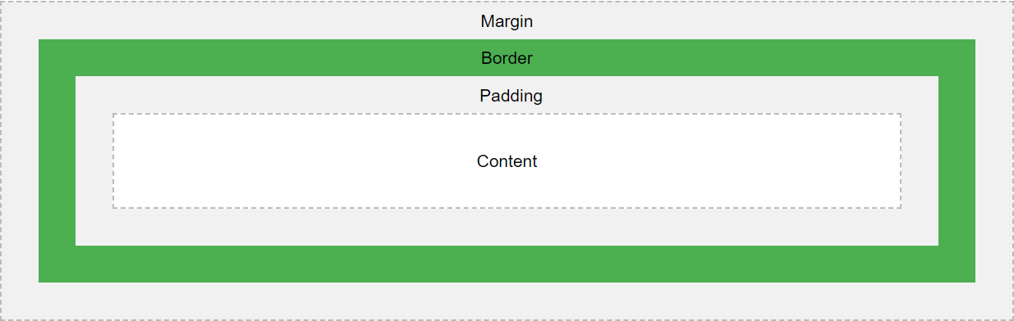
Padding is closest to the content, then the border, then the margin (PBM).

Height and Width
Height and width apply to many HTML elements.
height
width | Block items have a width of 100%. This can change the width of a block item.
max-width
auto - This is default. The browser calculates the height and width
length - Defines the height/width in px, cm etc.
% - Defines the height/width in percent of the containing block
initial - Sets the height/width to its default value
inherit - The height/width will be inherited from its parent value

t r b l
1 arg: all 4 sides;
2 args: top/bottom, sides;
3 args: top, left/right, bottom;
4 args: top right bottom left ("trouble")

Padding
padding-top  padding-right  padding-bottom  padding-left | All four padding properties can have the following:  auto - the browser calculates the margin and centers the element horizontally  Size (e.g. em, %, vw, etc.)  inherit - specifies that the margin should be inherited from the parent element
padding: t r b l | Set all 4 values (trouble)

Borders
border-style | dotted, dashed, solid, double, groove, ridge, inset, outset, none, hidden
border-width: t r b l | Set all 4 values (trouble)
border-color: t r b l | Same as border-width
border-radius | For rounded corners
border-top
border-right
border-bottom
border-left
border | size, style, color

Margins
margin-top  margin-right  margin-bottom  margin-left | auto - the browser calculates the margin and centers the element horizontally  Size - specifies a margin in px, pt, cm, etc.  % - specifies a margin in % of the width of the containing element  inherit - specifies that the margin should be inherited from the parent element
margin: t r b l | Set all 4 values

Outline
Outline differs from borders! Unlike border, the outline is drawn outside the element's border, and may overlap other content. Also, the outline is NOT a part of the element's dimensions; the element's total width and height is not affected by the width of the outline. An element's size is determined by the outside of its margin.
outline-style | solid, dotted
outline-color
outline-width
outline-offset
outline

Background
Background can be applied to many HTML elements, not just the body.
background-color:red; | named color, rgb color (rgb or rgba), hex color
background-image:url("paper.gif");
background-repeat:repeat-x | repeat-x, repeat-y, repeat, no-repeat
background-attachment:fixed | fixed (doesn't repeat when you scroll), scroll
background-position | If you only specify one keyword, the other value will be "center". Options:  left top  left center  left bottom  right top  right center  right bottom  center top  center center  center bottom
background | order of arguments: background-color, background-image, background-repeat, background-attachment, background-position
opacity | 0.0-1.0: 0=transparent, 1=opaque

Images
body{background-image:url(pic.jpg);} | Makes pic.jpg the background for the body. Always tiles the image.
background-repeat:no-repeat; | Stops tiling; does NOT repeat the background
background-repeat:repeat-x; | Repeats an image horizontally
background-repeat:repeat-y; | Repeats an image vertically
background-position:h v; | Pick for h: left, center, right. Pick for v: top, center bottom
background-size:cover | Makes the image cover the whole page width
Brighten an image when the mouse hovers:
img { opacity: 0.5; }
img:hover { opacity: 1.0; }

Lists
ul | unordered list | list-style-type: circle, square, upper-alpha, lower-alpha, upper-roman, lower-roman
ol | ordered list
li | list item

Lists
display:inline | Make list items inline (they are block items by default)
display:inline-block | Like inline elements but can have their own width and height
list-style-type | none, disc, circle, square, decimal, upper-alpha, lower-alpha, upper-roman, lower-roman
list-style-position | outside, inside
list-style-image:url("pic.gif");

Tables
Selectors: table, thead, tfoot, th, tr, td
border:1px solid black;
border-collapse:collapse; | Specifies whether or not table borders should be collapsed
border-spacing | Specifies the distance between the borders of adjacent cells
width
height
text-align | Specifies horizontal alignment in cells: left, right, center
vertical-align | Specifies vertical alignment in cells.
tr:hover {background-color: #f5f5f5} |  | Makes a row change color when mouse hovers
tr:nth-child(even) {background-color:blue;}
tr:nth-child(odd) {background-color:white;}
tr:first-child | First child selector: select first row
tr:last-child | Last child selector: select last row

Links/Anchors
Apply color, background color, font, font size, etc. This can be applied to elements other than links, too.
a:link | normal unvisited link
a:visited | a link that has been visited
a:hover | a link when the user is hovering over it. NOTE: hover must follow link and visited
a:active | a link the moment it is clicked. NOTE: active must follow hover!

Links as buttons
display:inline-block | Makes them into blocks, but can still have more than one on a line.
background-color: | #xxxxxx
color
padding
text-align
text-decoration:none | Remove underlines. Used most often to remove underlines from links
box-shadow:h v radius color | h=horizontal offset, v=vertical offset

Link as a button example
a:link, a:visited {
background-color: #f44336;
color: white;
padding: 14px 25px;
text-align: center;
text-decoration: none;
display: inline-block;
}
a:hover, a:active {
background-color: red;
}

Icons
https://www.w3schools.com/icons/icons_reference.asp

Alignment
margin:auto | Centers a block between left and right margins.
text-align:center | Sets alignment of text within a block.
text-align:left
text-align:right
To center an image, make it into a block element first:
img {
display: block;
margin: auto;
width: 40%;
}

Display
Often used to convert a block element (e.g. <p>) to inline or an inline element (like <a>) to block.
display:inline | Make list items (or any block item) inline (they are block items by default)
display:block | Make inline items into block items
display:inline-block | Like inline elements but can have their own width and height
display:none | Makes the element invisible. Page looks as if the element is not there.

Position
position:static; | Default. Not affected by t, r, b, l
position:relative; | Item positioned relative to its normal position, e.g. left:30px; indents it 30 px
position:fixed; | Positioned relative to the viewport. NEVER MOVES. right:0; bottom:0;  0px from the right edge, 0px from the bottom; Use with position:fixed.
position:absolute; | Relative to nearest POSITIONED (not static) ancestor

Floating
float:left | Moves element left, items below move up on right; width property is required
float:right | Moves element right, items below move up on left
float:none | Turns float off

Clear

Overflow
overflow:visible | Default. The overflow is not clipped. It renders outside the element's box
overflow:hidden | The overflow is clipped, and the rest of the content will be invisible
overflow:scroll | The overflow is clipped, but a scrollbar is added to see the rest of the content
overflow:auto | If overflow is clipped, a scrollbar should be added to see the rest of the content

Resizing
This example automatically resizes when the window gets smaller than 500px.
div.ex2 {
max-width: 500px;
margin: auto;
border: 3px solid #73AD21;
}

All pseudo-classes
Selector | Example | Example description
:active | a:active | Selects the active link
:checked | input:checked | Selects every checked <input> element
:disabled | input:disabled | Selects every disabled <input> element
:empty | p:empty | Selects every <p> element that has no children
:enabled | input:enabled | Selects every enabled <input> element
:first-child | p:first-child | Selects every <p> elements that is the first child of its parent
:first-of-type | p:first-of-type | Selects every <p> element that is the first <p> element of its parent
:focus | input:focus | Selects the <input> element that has focus
:hover | a:hover | Selects links on mouse over
:in-range | input:in-range | Selects <input> elements with a value within a specified range
:invalid | input:invalid | Selects all <input> elements with an invalid value
:lang(language) | p:lang(it) | Selects every <p> element with a lang attribute value starting with "it"
:last-child | p:last-child | Selects every <p> elements that is the last child of its parent
:last-of-type | p:last-of-type | Selects every <p> element that is the last <p> element of its parent
:link | a:link | Selects all unvisited links
:not(selector) | :not(p) | Selects every element that is not a <p> element
:nth-child(n) | p:nth-child(2) | Selects every <p> element that is the second child of its parent
:nth-last-child(n) | p:nth-last-child(2) | Selects every <p> element that is the second child of its parent, counting from the last child
:nth-last-of-type(n) | p:nth-last-of-type(2) | Selects every <p> element that is the second <p> element of its parent, counting from the last child
:nth-of-type(n) | p:nth-of-type(2) | Selects every <p> element that is the second <p> element of its parent
:only-of-type | p:only-of-type | Selects every <p> element that is the only <p> element of its parent
:only-child | p:only-child | Selects every <p> element that is the only child of its parent
:optional | input:optional | Selects <input> elements with no "required" attribute
:out-of-range | input:out-of-range | Selects <input> elements with a value outside a specified range
:read-only | input:read-only | Selects <input> elements with a "readonly" attribute specified
:read-write | input:read-write | Selects <input> elements with no "readonly" attribute
:required | input:required | Selects <input> elements with a "required" attribute specified
:root | root | Selects the document's root element
:target | #news:target | Selects the current active #news element (clicked on a URL containing that anchor name)
:valid | input:valid | Selects all <input> elements with a valid value
:visited | a:visited | Selects all visited links

2D Transforms
transform: translate(50px, 100px); | Moves the element
transform: rotate(20deg); | Rotates the element
transform: scale(2, 3); | Sets X and Y scale

Transitions
CSS transitions allow you to change property values smoothly, over a given duration.
transition-timing-function: | linear, ease, ease-in, ease-out, ease-in-out
transition-delay: | 2s (2 seconds)
transition-property: | width, height, etc.
transition-duration: | 2s (2 seconds)
transition: | Combines all four of above properties. Order of arguments:  property-name duration easing-function delay

div {
width: 100px;
height: 100px;
transition: width 2s; /* Any width transition will take 2 seconds */
}

div:hover {
width: 300px; /* Will take 2 seconds to go from 100px to 300px */
}

Animations
When you specify CSS styles inside the @keyframes rule, the animation will gradually change from the current style to the new style at certain times. To get an animation to work, you must bind the animation to an element.
The following example binds the "example" animation to the <div> element. The animation will last for 4 seconds, and it will gradually change the background-color of the <div> element from "red" to "yellow":

/* The animation code */
@keyframes example {
from {background-color: red; }
to {background-color: yellow;}
}
/* The element to apply the animation to */
div {
width: 100px;
height: 100px;
background-color: red;
animation-name: example;
animation-duration: 4s;
}

Grids
To use a grid, add the following to the parent element:
display:grid; | Creates a block grid.
display:inline-grid; | Creates an inline grid. Probably not needed often.
To adjust between grid elements:
grid-column-gap | Sets gap between columns
grid-row-gap | Sets gap between rows
grid-gap | Sets both gaps to the same value.

Grid columns
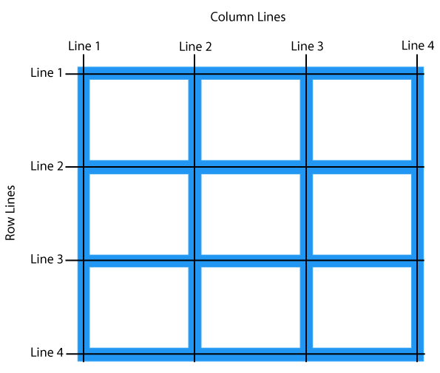

Easy way to lay out a grid:
item1, item2, item3, and item4 are IDs of elements. item1 will appear in the side grid boxes. item2 will appear in the header grid boxes, and item3 will appear in the footer grid boxes and item4 will appear in the article grid boxes. The template areas must form a rectangle. To leave an unused grid box, put a period in its grid-template-area.
#item1 {grid-area: side;}
#item2 {grid-area: header;}
#item3 {grid-area: footer;}
#item4 {grid-area: article;}
.grid-container {
grid-template-areas: 'side header header header header';
'side article article article article';
'side footer footer footer footer';
}
side | header | header | header | header
side | article | article | article | article
side | footer | footer | footer | footer

