ASP03-Notes-HW-SessionState

ASP.NET session state enables you to store and retrieve values for a user as the user navigates ASP.NET pages in a Web application.

Session State is the feature in ASP.NET that maintains the session information. It stores data (like user preferences, shopping cart contents, or login status) on the server so it can be reused during the user's visit to the site.

// Store a value
Session["Username"] = "John";

// Retrieve the value later
string user = (string)Session["Username"];

Session: This is a built-in object in ASP.NET that keeps track of information (state) for each user who visits the web application.
["Username"]: This is the key to store or retrieve data from the session.
= "John": We are assigning the value "John" to the key "Username" for this user's session.

This way, the app remembers who the user is until their session expires (e.g., they close the browser or it times out).

Advantages of Using Session State:
- Maintains user data across pages: Session state allows you to keep user-specific data (like login info or form data) as they navigate through the site.
- Server-side storage: Since session data is stored on the server, it’s more secure than storing it on the client side.

https://www.youtube.com/watch?v=FxFVgtdnZGE

Homework:

Page 1:

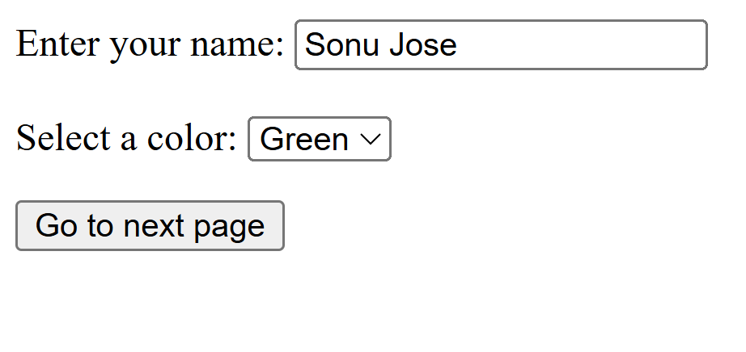

Page 2:



