ASP #2: Postbacks

Web Control Events and AutoPostBack
When you send a request for an ordinary HTML page to a web server (file extension is htm or html), it retrieves the page you requested and sends it back to you. Then it forgets all about you and waits for its next request.
When you send a request for an ASP.NET page to a web server (file extension is aspx), this happens:
- The web server examines the file extension, sees that it is aspx and hands the page off to the ASP.NET server.
- The ASP.NET server executes the page and creates an equivalent HTML page.
- The ASP.NET server runs code in the Page.Load event handler (in your "code behind" file).
- The final version of the HTML page is rendered.
- The final version of the HTML page is returned to the browser.
After the user receives the requested page, he may click on a button (or possibly some other control) that generates a postback. A postback occurs when a web page is sent back to the server for further processing. The first time a user requests a page, it is not a postback. All subsequent round trips to the server are postbacks. When a postback occurs, the following happens:
- The web server examines the file extension, sees that it is aspx and hands the page off to the ASP.NET server.
- The ASP.NET server executes the page and creates an equivalent HTML page. Note that this time, the page will almost certainly be different from the original due to the user entering some data before the postback.
- The ASP.NET server runs the Page.Load event handler (in your "code behind" file).
- The ASP.NET server runs any other event handlers that may have been triggered by the user's actions.
- The final version of the HTML page is rendered.
- The final version of the HTML page is returned to the browser.

Web control events
The button click event and the image button click event: All web input controls support automatic postbacks, but only the button control and the image button control automatically cause a postback for the click event.
The following events support postbacks, but not automatically. If you want one of these events to cause a postback, you must explicitly say so.
- The TextChanged event of the TextBox control. Note that the TextChanged event only fires when the focus leaves the TextBox, not on every keystroke that is entered in the TextBox.
- The CheckedChanged event of the CheckBox and RadioButton controls.
- The SelectedIndexchanged event of the DropDownList, ListBox, CheckBoxList, and RadioButtonList controls.
Sometimes you may want to respond immediately to an input event, and sometimes it may be ok to wait until the user clicks on a button (which will automatically cause a postback to occur). If you want to respond "immediately", you must force the control to generate a postback by setting its AutoPostBack property to true.
This is the order of events that occurs when a postback occurs (the ASP server is doing this):
- A Page object is created from the .aspx file.
- The Page.Init event occurs.
- Controls are repopulated with information from the view state.
- The Page.Load event occurs.
- All other events occur (like the click and changed events).
- The Page.PreRender event occurs.
- Control information is stored in the view state.
- The HTML for the page is rendered.
- The Page.Unload event occurs.
- The Page object is released from memory.
Note that all ten of these things occur on the ASP.NET server. It is all done on the server side.

An Event Tracker Application
Create a new Project: File | New | Project | Web | ASP.NET Empty Web Application. Call it ASP02EventTracker.
Add a new page: Project | Add New Item | Web | Web Form. Name it Default.aspx.
Add the following:
- A TextBox called txt
- A CheckBox called chk
- A RadioButton called opt
- A ListBox called lstEvents
All of the above controls should have the following by default:
runat="server"
Add the following to all of them except the ListBox:
AutoPostBack="True"
To the TextBox add:
OnTextChanged="CtrlChanged"
To the CheckBox and both RadioButtons add:
OnCheckedChanged="CtrlChanged"
And for the ListBox, add the following:
Width="355px" Height="150px"

Your code behind file should look like this:
public partial class _Default : System.Web.UI.Page
{
protected void Page_Load(object sender, EventArgs e)
{
Log("---Page_Load---");
}

protected void Page_PreRender(object sender, EventArgs e)
{
Log("Page PreRender");
}

protected void CtrlChanged(Object sender, EventArgs e)
{
string ctrlName = ((Control)sender).ID;
Log(ctrlName + " changed.");
}

private void Log(string entry)
{
lstEvents.Items.Add(entry);
lstEvents.SelectedIndex = lstEvents.Items.Count - 1;
}
}

Another one-page web application
Create the following web page. Call your project ASPGreetingCard.
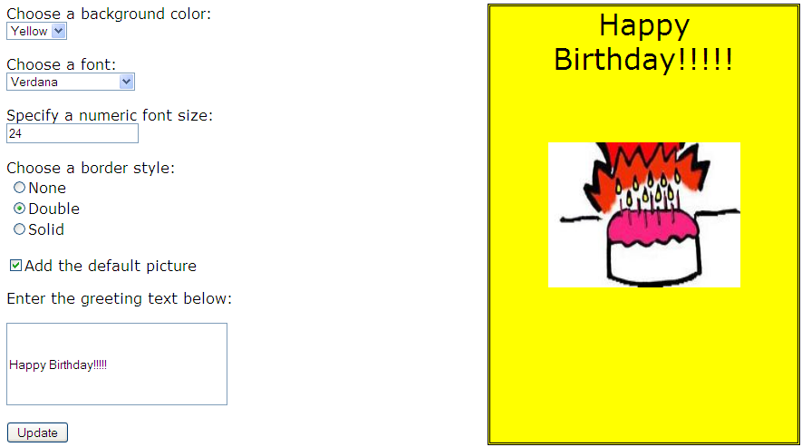
Controls on the left side:
- ddlBackColor (a DropDownList)
- ddlFontName (a DropDownList)
- txtFontSize (a TextBox)
- lstBorder (a RadioButtonList)
- chkPicture (a CheckBox)
- txtGreeting (a TextBox)
- btnUpdate (a Button)
Controls on the right side:
- pnlCard (a Panel—a container for the greeting and the image)
- lblGreeting (a Label (inside of the panel))
- imgDefault (an Image (inside of the panel))

Setting the control values at Run Time
Instead of filling the controls at design time, we will fill the list controls at the time the form loads. Put the following in the PageLoad event procedure.

Color options drop-down list
Set the color options to: "White", "Red", "Green", "Blue", "Yellow". Note that we can use strings for color names. The following code adds a string to the Items collection of the ddlBackColor drop-down list.
ddlBackColor.Items.Add("White");
ddlBackColor.Items.Add("Red");
ddlBackColor.Items.Add("Green");
ddlBackColor.Items.Add("Blue");
ddlBackColor.Items.Add("Yellow");
Test your web site. Click on the Update button more than once and see what happens! You get everything in your two lists added on again! This is because every time we go back to the server the Form Load method gets executed again! So we need to add the following to the top of the Form Load method and put the five instructions inside of curly brackets:
if (!this.IsPostBack)
So if we are NOT doing a PostBack (i.e. we are doing it the first time), we will add the colors. Otherwise (when we ARE doing a PostBack) we will NOT add the colors.

Font options drop-down list
Set the font options to: "Times New Roman", "Arial", "Verdana", "Tahoma". Note that font names are strings. Again, this goes in the PageLoad event procedure.
ddlFontName.Items.Add("Times New Roman");
ddlFontName.Items.Add("Arial");
ddlFontName.Items.Add("Verdana");
ddlFontName.Items.Add("Tahoma");
Test your web site.

Font size text box
It's not necessary to initialize the font size text box, but we may as well put a default value in there. Note that we could do this in design view, but let's do it in the PageLoad event procedure:
txtFontSize.Text = "24";

Border Style Radio Button List
Since the colors and font names can be strings, it was easy to add them to the list. When we want to retrieve the values, we can just retrieve the strings. However, the border styles are an enumeration (integers), so we need to add two things to each list item: (1) add the text, and (2) add the integer value. To do this, we need to create new ListItems. For each ListItem, we need to add some text and a value. Note that the ToString method of the BordeStyle class returns the name of the enumeration (e.g. "None") as a string. But it actually represents an integer, so we need to save the integer, which means that we must first convert it to an integer and then convert it to a string. Add the following in the PageLoad event procedure.
// ListItems are objects. Create a new one.
ListItem item = new ListItem();
// Convert the border style to a string for display
item.Text = BorderStyle.None.ToString();
// Get its integer equivalent and convert the integer to a string
item.Value = ((int)BorderStyle.None).ToString();
// Add it to the list
lstBorder.Items.Add(item);

item = new ListItem();
item.Text = BorderStyle.Double.ToString();
item.Value = ((int)BorderStyle.Double).ToString();
lstBorder.Items.Add(item);

item = new ListItem();
item.Text = BorderStyle.Solid.ToString();
item.Value = ((int)BorderStyle.Solid).ToString();
lstBorder.Items.Add(item);
Test your program.
Since this is a radio button list, we should select one of the options. We can select the first option by setting the value of the SelectedIndex property. Let's set it to 0 in the PageLoad event procedure:
lstBorder.SelectedIndex = 0;

The greeting text box
The greeting text box allows the user to enter a greeting message that will appear in the card. You could put a default greeting here (e.g. "Happy Birthday!"). This goes in the PageLoad event procedure.
txtGreeting.Text = "Happy Birthday!";

The Image
We need to set a value for the image, too. Put images in the Images folder in your project. Find one of your own. Then set the ImageURL property to the name of the file. Be sure to put the name of the Images folder before the name of the file. Add the following in the PageLoad event procedure.
imgDefault.ImageUrl = "Images/yourPictureName.png";
Test your program.

The command button
The command button should take all of the user's settings and create a greeting card. In the command button's Click event procedure, you need to:
- Get the background color and set the panel's background color.
- Get the font name and set the greeting label's font name.
- Get the font size and set the greeting label's font size.
- Get the border style and set the panel's border style.
- Get the check box value and decide whether to show the default picture.
- Get the greeting and put it in the greeting label.
Double-click on the button and go to its Click event procedure.

The panel's BackColor Code:
this.pnlCard.BackColor =
We must put a Color on the right hand side of this statement. If we put this:
this.ddlBackColor.SelectedItem;
we will get an error because the type of SelectedItem is ListItem.
And if we do this:
this.ddlBackColor.SelectedItem.ToString();
We will still get an error because we are trying to copy a string into a color. So we must use the Color.FromName() method. To use this, add the following:
using System.Drawing;
Then add this in the button's click event procedure:
this.pnlCard.BackColor = Color.FromName(this.ddlBackColor.SelectedItem.ToString());
We could also do this:
this.pnlCard.BackColor = Color.FromName(this.ddlBackColor.SelectedItem.Text);

The greeting label's Font Name:
this.lblGreeting.Font.Name =
The font name is a string, so we need a string on the right hand side. The items in the list are of type ListItem, so we can't put an item from the list on the right-hand side, unless we convert it to a string. There are two ways to do this. Add one of the following to the button's click event procedure:
this.lblGreeting.Font.Name = this.ddlFontName.SelectedItem.ToString();
this.lblGreeting.Font.Name = this.ddlFontName.SelectedItem.Text;

The font size:
if (Convert.ToInt32(this.txtFontSize.Text) > 0)
this.lblGreeting.Font.Size = Convert.ToInt32(this.txtFontSize.Text);
else
this.lblGreeting.Font.Size = 10;
The Font Size is an integer, so we need to convert the text from the text box into an integer. That's what Convert.ToInt32 does. Try running this but with an invalid integer and see what happens! It blows up with an error message.
So we need something else. The Int32 class has a TryParse method that will accept a string to parse, and an integer as an "out" parameter. If the string can be parsed into an Int32, its integer value will be in the "out" parameter and it will return the value true. if it cannot be parsed, it will return the value false. Note that the variable size must be declared as an int.
int size;
if (Int32.TryParse(this.txtFontSize.Text, out size))
this.lblGreeting.Font.Size = Convert.ToInt32(this.txtFontSize.Text);
else
this.lblGreeting.Font.Size = 10; // Default

The panel's border style:
this.pnlCard.BorderStyle = (BorderStyle) (Int32.Parse(this.lstBorder.SelectedItem.Value));

The check box:
if (chkPicture.Checked == true)
imgDefault.Visible = true;
else
imgDefault.Visible = false;

The label's greeting text:
lblGreeting.Text = txtGreeting.Text;

