ASP.NET Assignment #1
Create an ASP.NET application that will compute the future value of an investment. Your web page should look something like this:
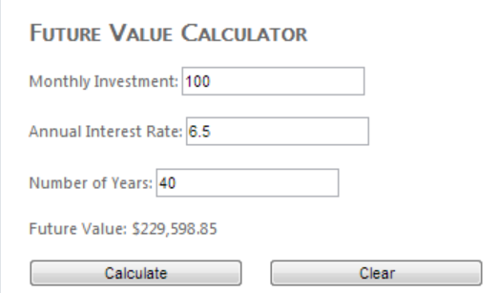

The Calculate button
The Calculate button should use the data in the three text boxes to compute the future value.
Monthly Investment is a double (or decimal).
Annual Interest Rate is a double (or decimal) and will be entered as a percent. That is, 6.5% will be entered as 6.5, not .065. Your program must divide it by 100 to make it into its correct decimal value.
Number of Years is an int. It is your choice whether to accept a number like 30.5 for years, but if you do, you must use either 30 or 31 for the years value. We will not deal with fractions of years.
We will assume that all input is valid (all input values are numeric; we don't have to worry about the user entering letters or other characters).
Compute the future value when the user clicks on the Calculate button. You may compute the future value by using a loop, looking up the formula, or any other way that you can think of. The assumption that we will make is that the money will always be deposited at the beginning of the month and interest will be compounded monthly. So if the annual rate is 6.00% (0.06), the monthly rate will be 0.5% (0.005). If you use my input numbers above, you should get the same future value that I got. If you use my numbers and assume payments at the end of the month, you should get $228,361.89. If you get this answer, change your program to allow for the payments being made at the beginning of the month. Note that a function may give you a negative number. If so, just multiply it by -1 to make it positive before displaying it.

The Clear button
When the user clicks on the Clear button, clear the three input text boxes (put the empty string in them) and put the value "$0.00" in the future value label.

Formatting
You should have a title as in the example above. Add your names below the buttons. Use a sans-serif font. Put borders around text boxes. Other than that, formatting is up to you. You are all very familiar with CSS, so feel free to add a <style> element to the head of your HTML or a style.css file to format your web page as you please. You may also use the Properties window of Visual Studio to modify the properties of any object.

Program Style
Use these prefixes: txt for text boxes, lbl for labels, and btn for buttons. As always, use descriptive names.

What to hand in
Zip your entire project and put it in the drop box.

