Tableau: Adding actions to dashboards

# Actions

Actions allow users to interact directly with the data in a dashboard. There are 3 types of actions:

1. Highlight action
2. Filter action
3. URL action

## Highlight actions

A highlight action causes some marks to be highlighted while others are dimmed. To create a highlight action, you must activate/select marks in the *source sheet* to highlight marks on the *target sheet*.

## Filter actions

A filter action filters your data, showing only the targeted data on multiple worksheets. To create a filter action, you must activate/select marks in the *source sheet* to filter marks on the *target sheet*.

## URL actions

URL actions connect users to web-based resources. The user will click the *source sheet* and the *target* is a URL or web resource.

Actions can be activated in one of three ways:

1. Hover: activated when the user hovers over a data mark
2. Select: activated when the user clicks on a data mark
3. Menu:

## Highlight actions

To add a highlight action, click on the *Dashboard* menu item, then click on *Action*. The *Actions* dialog box shows all existing actions. You can do the following:

1. Give your action a name.
2. Select the source sheet(s)
3. Select the target sheet(s)
4. Whether you want to run the action on *Hover, Select,* or *Menu*.

Internet Usage Example

Use *World Internet Use, 1960-2017.xlsx* to create the following.

# Data visualization #1: map of internet use

Each dot in the map represents the percent of Internet use for that country. Since there is data for multiple years, we can't sum (we'll get a number way over 100%). It probably doesn't make sense to take the average, either. It seems like a more reasonable number would be the MAX (which will almost always be the most recent year). The dots use both color and size to represent Internet usage. A red/gold/green scale has been applied with 6 discrete values and the colors reversed. The circles have both a black border and a gray halo. A filter on *Country Name* has been added and is visible on the right side. The worksheet tab has been given the name *Internet Use by Country*.

# Data visualization #2: Internet use by country over time

Years are along the bottom. Percent of internet use is on the side. Lines have been color-coded by country. A time filter is visible on the right, and a filter has been applied to show only years after 1990, because all Internet use before then was virtually 0. The worksheet tab has been named *Internet Use Over Time*.

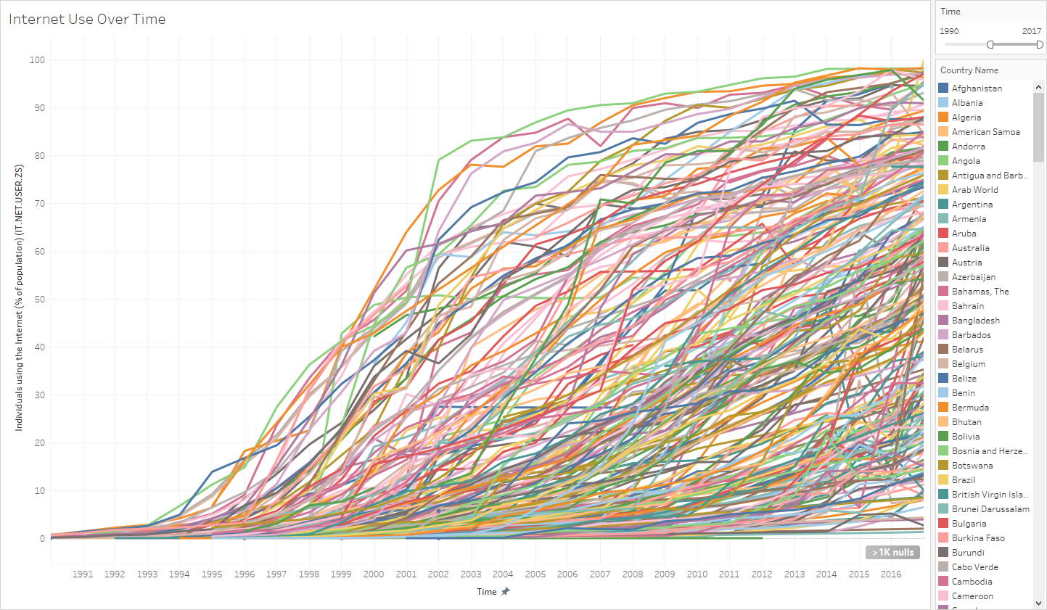

# Dashboard

Use the two visualizations created above to create the following dashboard. The legend for the map has been made into a "floating" element and has been moved to the map surface. Its title has also been changed, it has been widened, and it has a border.

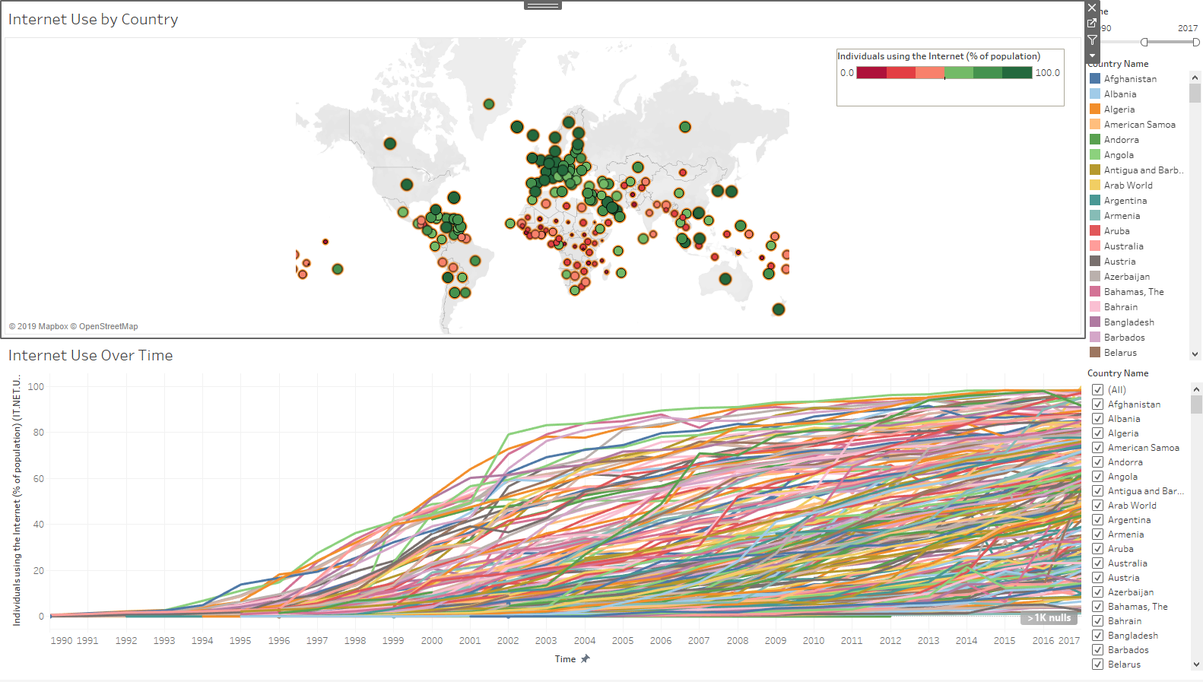

# Adding actions: Highlight

Let's add a highlight action that allows the user to hover over a country and see the line below.

Click on *Dashboard* | *Actions* to bring up the *Actions* dialog box.

Click on *Add Action* and click on *Highlight*.

Name your action *Show Timeline*.

For *Source Sheets*, turn on *Internet Use by Country*, and turn off *Internet Use Over Time.*

For *Target Sheets,* turn on *Internet Use Over Time*, and turn off *Internet Use by Country*.

For *Run Action On*, click on *Hover*.

Click on *OK*.

Now hover your mouse over some dots on the map. The corresponding line should be highlighted below.

# Adding actions: Select

Let's add a highlight action that allows the user to click on a country and see the line in the line chart below.

Click on *Dashboard* | *Actions* to bring up the *Actions* dialog box.

Click on *Add Action* and click on *Filter*.

Name your action *Show Country on Timeline*.

For *Source Sheets,* turn on *Internet Use by Country*, and turn off *Internet Use Over Time*.

For *Target Sheets*, turn on *Internet Use Over Time*, and turn off *Internet Use by Country.*

For *Run Action On*, click on *Select*.

For *Clearing the Selection will,* click on *Show all Values*. This will cause all of the country dots to appear when the user clicks off of the selected line in the line chart at the bottom.

Click on *OK*.

Now click your mouse on a country on the map. The corresponding country line should be highlighted in the line chart below, like this:

# Another select action

Let's reverse the previous example and allow the user to select a line and have the country highlighted in the map.

Click on *Dashboard* | *Actions* to bring up the *Actions* dialog box.

Click on *Add Action* and click on *Filter*.

Name your action *Show Country on map*.

For *Source Sheets*, turn on *Internet Use Over Time*, and turn off *Internet Use by Country.*

For *Target Sheets,* turn on *Internet Use by Country*, and turn off *Internet Use Over Time*.

For *Run Action On*, click on *Select*.

For *Clearing the Selection will,* click on *Show all Values*. This will cause all of the country dots to appear when the user clicks off of the selected line in the line chart at the bottom.

Click on *OK*.

# Adding actions: URL

Let's add a URL action that allows the user to click on a country and go to a web page with more information.

Click on *Dashboard* | *Actions* to bring up the *Actions* dialog box.

Click on *Add Action* and click on *URL*.

Click on the arrow on the right end of the *Name* textbox. A list of fields will appear. Click on *Country Name*. The text *<Country Name>* will appear in the text box. Copy this to the clipboard. We need this to create our URL (see below). Add the text *Link to* to the left of *<Country Name>.* The *Name* textbox should now read: *Link to <Country Name>*

For *Source Sheets*, turn on *Internet Use by Country* and turn off *Internet Use over Time*.

For *Run action on* turn on *Menu* (you do *not* want *Hover!*).

We need to provide a URL. In the URL text box, put the following: *https://en.wikipedia.org/wiki/<Country Name>*

Click on *OK*.

Now click your mouse on a country on the map. A popup will appear with a hyperlink that says *Link to <country name>* where *<country name>* has been replaced with the name of the actual country.