Tableau Dashboards

A dashboard lets you see many views (worksheets) at the same time.

Dashboard uses:

1. Monitoring dashboards can provide quick insight on data that may be frequently changing.
2. Exploration dashboards help the user answer his own questions about the data.
3. Informative dashboards help the user see and understand the data quickly by bringing together views that make a point or share specific information.

#### Example

The dashboard itself is on the right and takes up most of the screen area (shaded area below). It is the visualizations.

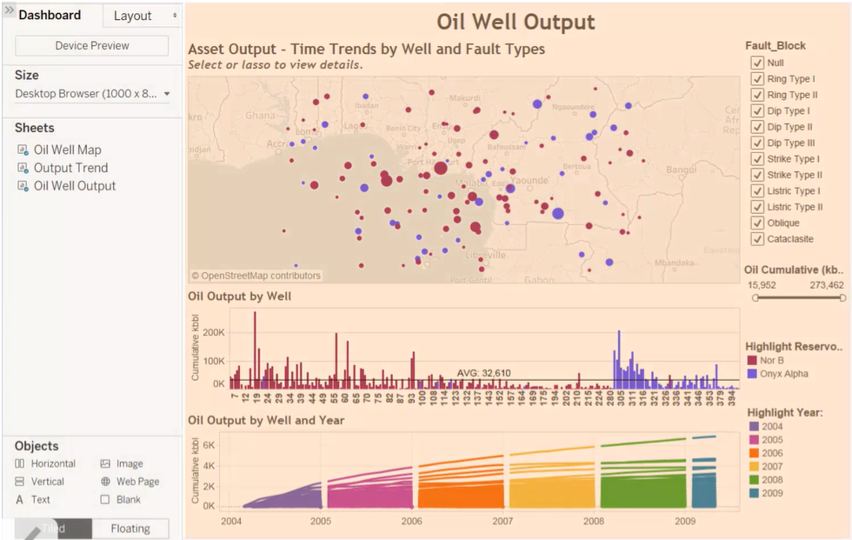

The editing panes are on the left:

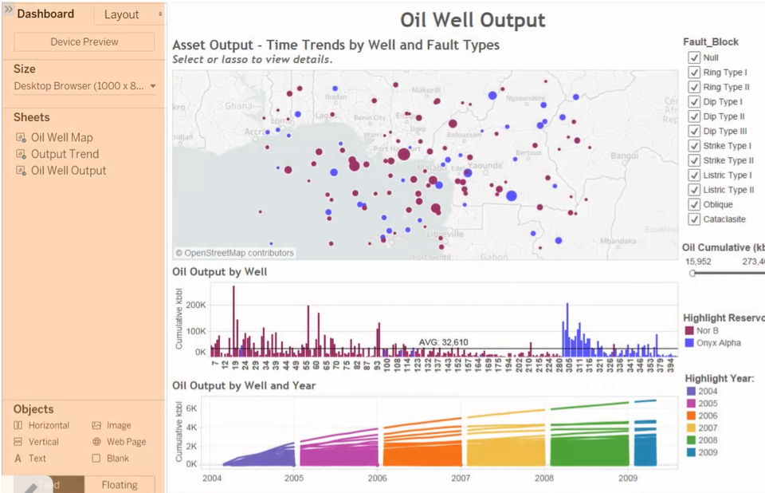

The *Dashboard* pane:

1. The *Device Preview* button lets you see what your dashboard will look like on various devices. You can turn this on and off (it's a toggle button).

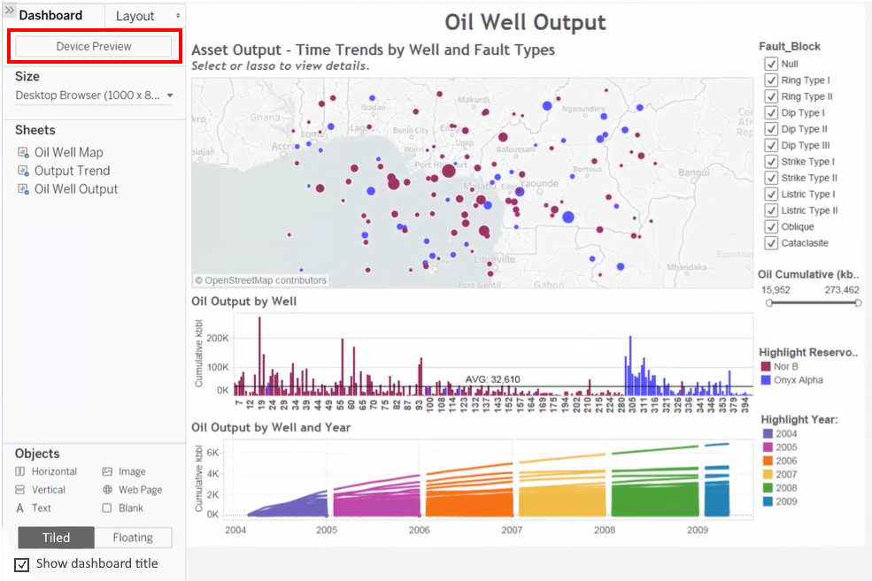

1. The *Size* drop-down allows you to choose the resolution of your visualization (and is closely related to the *Device Preview*).

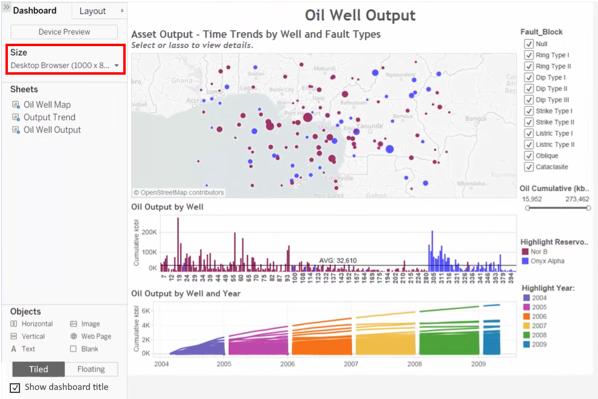

1. The *Sheets* area lists the views in this workbook:

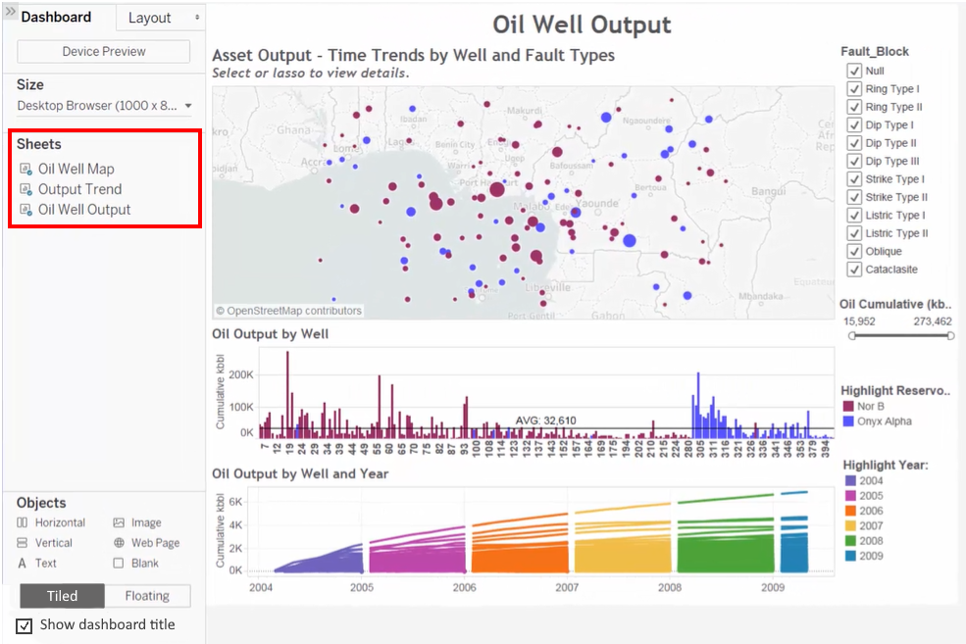

1. The *Objects* area lists external objects that can be added to your dashboard. You can drag these items to the dashboard and then answer the questions that appear in the dialog boxes that pop up.

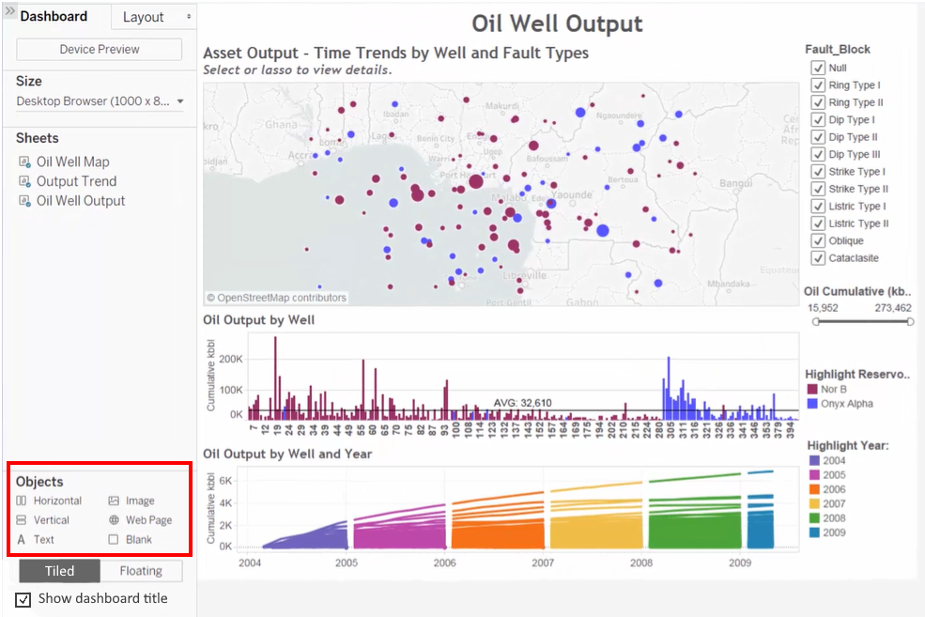

1. The *Tiled|Floating* determines how the objects are displayed. Tiled objects go into a grid. Floating objects can be positioned anywhere in the dashboard.

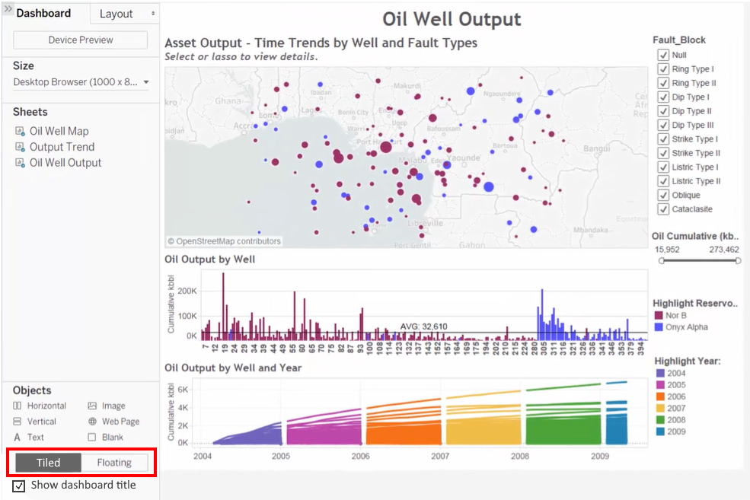

1. *Show dashboard title* will show/hide the dashboard title.

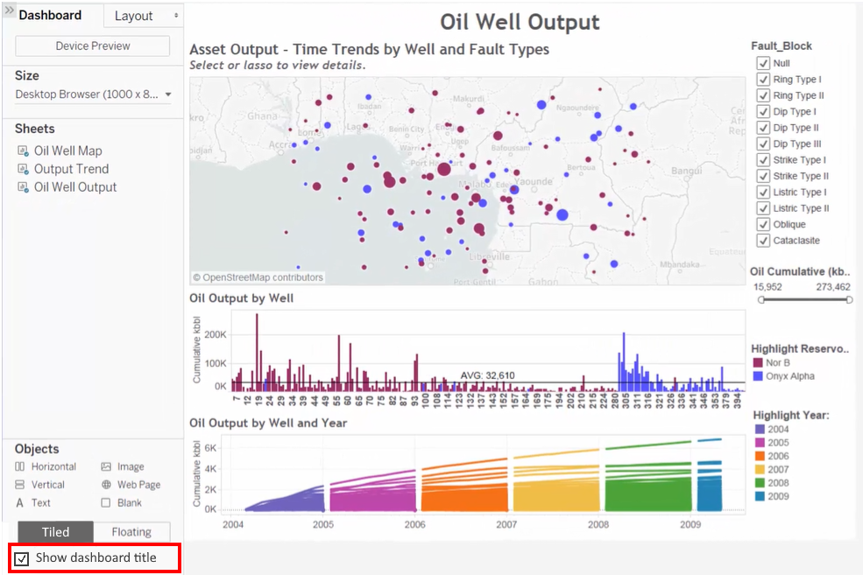

# Creating a new dashboard

To open a new dashboard, click on the *New Dashboard* tab below the data view.

Set the size of the dashboard before you start building your dashboard. Click on the down-arrow in the *Size* area in the *Dashboard* pane (on the left). Select *Desktop Browser* for now.

Turn on the title by clicking on the *Show dashboard title* button.

Add views to the dashboard by dragging sheets to the dashboard.

Objects can be re-sized by dragging the two-headed arrows on the borders of those objects. These are live views, and any changes made on the original worksheet will be reflected on the dashboard.

Legends on the right can be dragged and dropped to rearrange them.

Building a dashboard

Open Tableau and connect to the *Superstore Sales Training.xlsx* file.

# Sheet 1

Create a new worksheet called *Sales by Customer Segment* that looks like this:

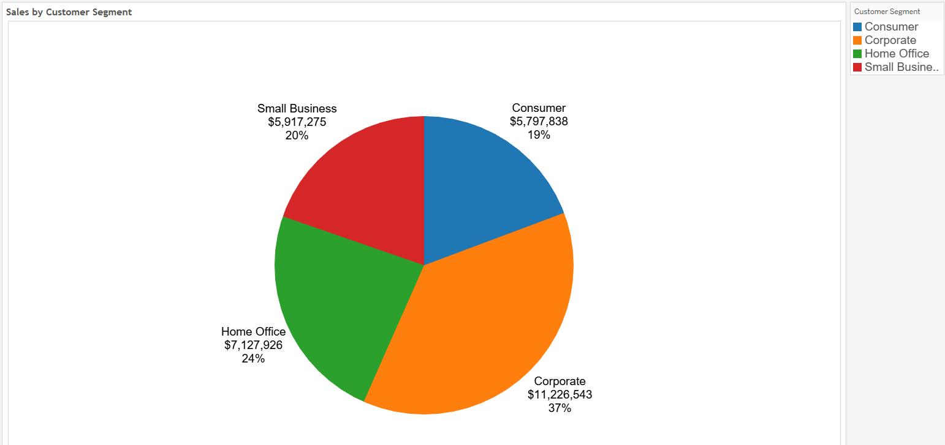

## Sheet 2

Create a new worksheet called *Sales by Country & Region* that looks like this. Add *Region* as a filter and display it on the right side. Use a different color palette than you used on the first chart.

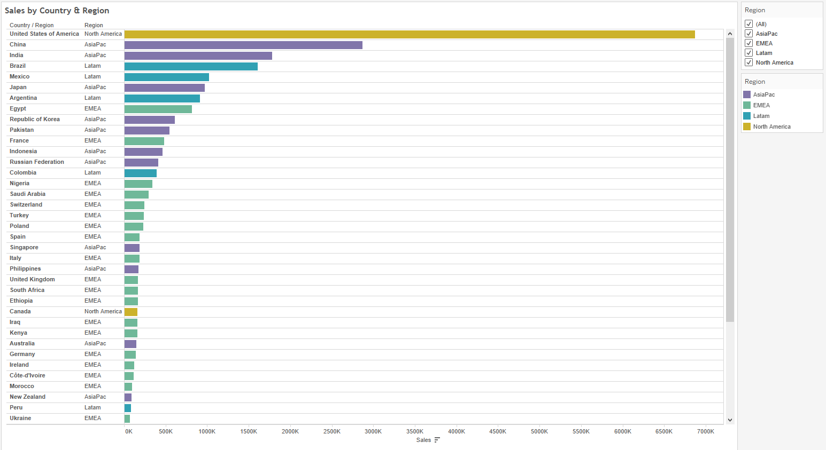

## Chart 3

Create a worksheet called *Sales vs. Profit*. It is a scatter plot that has *Sales* on the horizontal axis and *Profit* on the vertical axis and is broken down by category and segment. The points should be colored by *Customer Segment* (4 colors). There should be a filter to filter on *Customer Segment* on the right side. Use the same color palette that you used for the pie chart.

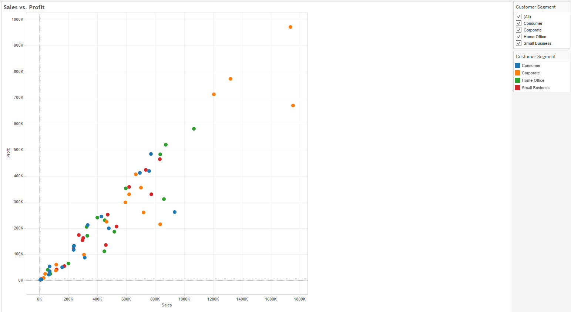

# The dashboard

We will create the following dashboard:

Create a new dashboard:

Name it *Sales Dashboard*:

Set the *Size* to *PowerPoint (1600x 900)*:

Select *Show dashboard title* to make the title visible:

Add all 3 views. Put the pie chart on the top left quadrant, the scatter plot on the right two quadrants, and the bar chart in the bottom left quadrant.

For the *Region* filter, click on its white-on-gray down-arrow. Click on *Apply to worksheets*. Select *All using this data source*:

For the *Customer Segment* filter, click on its white-on-gray down-arrow. Click on *Apply to worksheets*. Select *All using this data source*.

