Pie Charts: Showing Parts of the Whole

# Pie charts

From Wikipedia: *"A pie chart (or a circle chart) is a circular statistical graphic, which is divided into slices to illustrate numerical proportion. In a pie chart, the arc length of each slice (and consequently its central angle and area), is proportional to the quantity it represents.*

*Pie charts are very widely used in the business world and the mass media. However, they have been criticized, and many experts recommend avoiding them, pointing out that research has shown it is difficult to compare different sections of a given pie chart, or to compare data across different pie charts. Pie charts can be replaced in most cases by other plots such as the bar chart, box plot, dot plot, etc."*

## Some problematic pie charts.

### Bad pie chart #1

So many pieces that the visualization is meaningless.

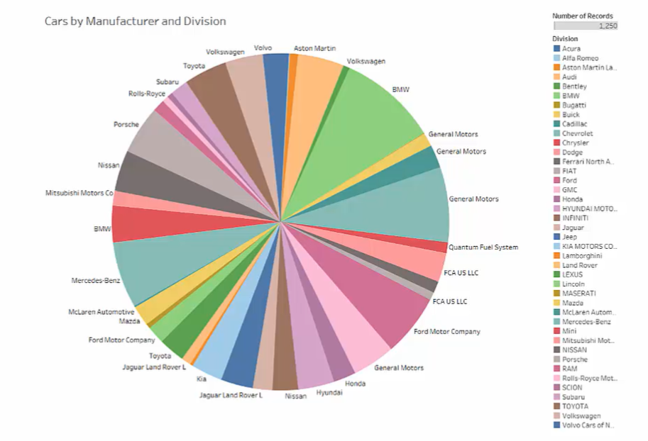

### Bad pie chart #2

3D pie charts misrepresent the data. DON'T USE 3D PIE CHARTS.

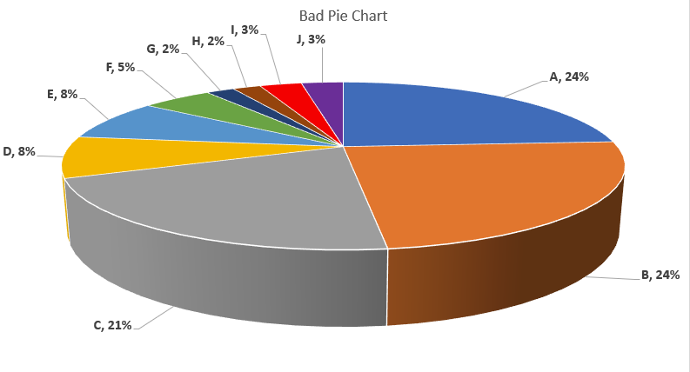

### Bad pie charts #3

In the charts below, the size of the pie represents the sales, the pieces of the pie represent the proportion of sales going to each Category.

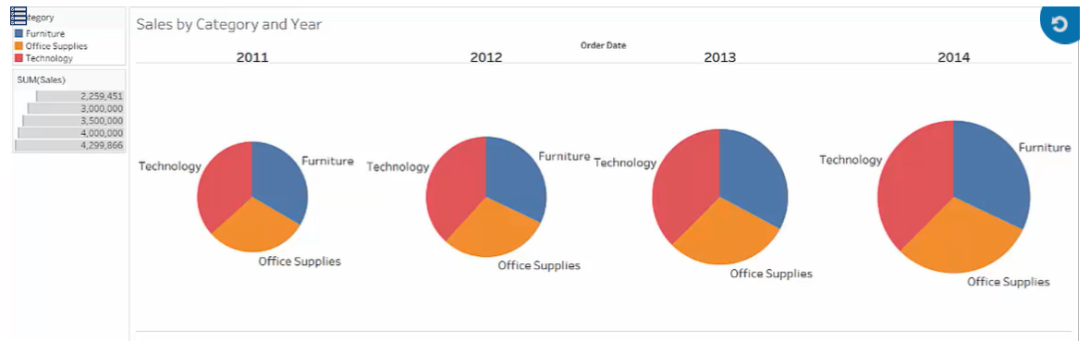

A better approach:

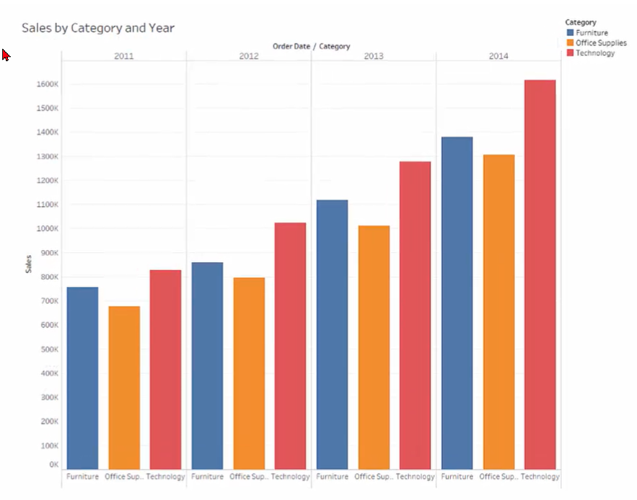

### Good pie chart #1

This pie chart actually conveys some information.

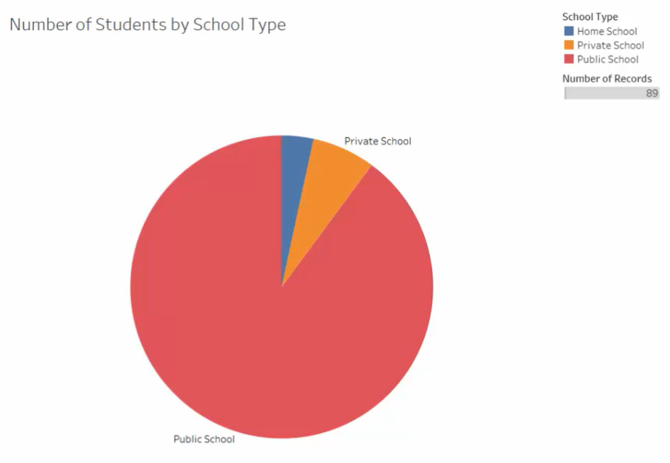

# Pie Chart Example #1

We will create a pie chart that shows the four customer segments in the Superstore data.

Open Tableau and connect to the *Superstore Sales Training.xlsx* file.

Select the *Orders* worksheet from Excel.

Create a new worksheet (Sheet 1).

To create a pie chart, select *Pie* from the *Marks* card drop-down list.

This adds an *Angle* button to the *Marks* card, which is only for making pie charts:

Drag *Sales* to the *Angle* button:

This will give us a pie that only has one value (and is therefore only one color):



Drag *Customer Segment* to the *Color* button:

This will display a different color for each of the four customer segments.

Drag *Sales* to the *Labels* button:

This will add a label with the sales total for each segment:

Drag *Customer Segment* to the *Labels* button:

This will add a customer label to each segment:

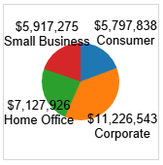

Change the *View* from *Standard* to *Entire View*:

The chart will expand to fill the work area:

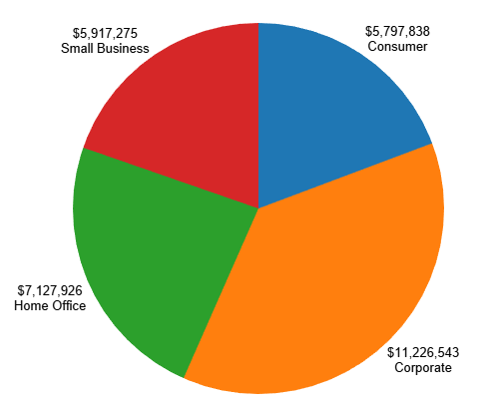

Possible changes:

1. Increase font size of labels.
2. Add percentages to the labels.

#### Increase font size:

Right-click on one of the labels and choose *Format…*.

In the *Format Font* dialog box that appears on the left side, click on the font button:

Click on the *Sheet* tab.

Under *Default*, select *Worksheet* and click on its down-arrow. Change the font to 12-point bold, black text:

#### Display percentages

Click on the *Analysis* tab.

Click on *Percentage of*.

Click on *Table*.

Percentages will now be displayed. However, the dollar values have now disappeared:

I want both, which means that we want the Sales value to have 2 labels. Getting both seems a little tricky. If we just drag Sales to the *Label* mark again, nothing changes, so it appears that we can't get two labels with the same measure. However, if we change the current *Sales* label to a percent before dragging it to the label mark again, it works.

Click on the down-arrow on the *SUM(Sales)* pill on the *Marks* card (the pill that has the "T" [text] icon next to it). Choose *Quick Table Calculation* and then click on *Percent of Total*.

NOW drag *Sales* to the *Label* mark again:

This time it works. After some rearranging on the *Marks* card, it looks like this:

# Pie Chart Example #2 (Show me)

Go to a blank worksheet.

Click on *Sales.*

Hold the control key down and click on *Region.*

Click on *Show Me*.

*Pie Chart* will be one of the options. Click on it.

Do the same things we did previously. Your end result should look like this:

Showing hierarchy with Tree Maps

Tree maps use nested rectangles to show hierarchical data as parts of a whole. The shapes help the eye to compare relative sizes.

How to build a tree map:

Bring one measure to Color and Size and one Dimension to Detail.

Tree maps do *not* use the Columns and Rows shelves. Everything goes into the *Marks* card.

# Tree Map Example #1

Open a new tab in your existing workbook, *Sheet 3*.

Drag *Sales* to *Color* and *Size* on the *Marks* card.

Drag *Country* to *Label*.

This will create the tree map and display the names of the countries. Note that rather than overlapping labels, Tableau leaves labels off of some of the rectangles. The data is still there, though. Just hover your mouse over a rectangle that does not have any visible text and the data will appear in a tool tip:

Drag *Sales* to the *Label* mark:

This will display the numbers associated with each rectangle:

Tree maps do not use the *Rows* or *Columns* shelf. This means that they do not have axes.

If you want more info available in tool tips (but not on the map itself), drag it to the *Tool Tip* button. Drag *Profit* to the *Tool Tip* button on the *Marks* card:

Profit will now show up in a tool tip if you hover the mouse over a rectangle:

You can edit the appearance of the tool tip. Click on the *Tool Tip* button. The *Edit Tool Tip* dialog box appears and you can add additional text and format the existing text. Increase the font size of the tool tip from 10 to 12:

You can add another dimension to the tree map. Drag *Region* to the *Color* button:

Your tree map now looks like this:

# Word Clouds

A tree map can easily be converted into a word cloud.

Change the mark type (currently *Automatic* on the *Marks* card; click on its dropdown arrow) to *Text*.

Your word cloud will look like this:

It doesn't look too good with the numbers, so remove them by dragging the existing SUM(Sales) (the one with the *Text* icon next to it) to the *Tool Tip* button. Now instead of appearing as part of the text of the map, it will only appear on the tool tip.

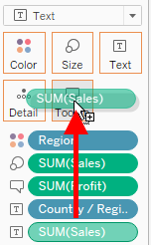

The US has a very long name. To shorten it, right-click on *Country/Region* in the *Dimensions* list. Click on *Aliases*. Scroll to *United States of America*. Change its alias to *United States* and click on *OK*. Your map should look something like this:

# Bubble charts

A tree map can also be converted into a bubble chart. A bubble chart is similar to a tree map, but each region is a circle (actually, a disk—a circle would just be the outline), or "bubble". To convert to a bubble chart, just select the mark type (currently either *Square* if we still have a tree map, or *Text* if we have a word cloud).

Your bubble chart looks like this:

You may want to edit labels and tool tips to make the chart more readable.

You can add more detail by adding a dimension to rows. Drag *Order Date* to the *Rows* shelf.

Your chart now looks like this (Change the *Fit* value to *Fit Width*):

