Crosstabs/Highlight Tables/Heat Maps

# Crosstabs

From surveyking.com: A cross tabulation (or **crosstab**) report is used to analyze the relationship between two or more variables. The report has the x-axis as one variable (or question) and the y-axis as another variable. This type of analysis is crucial in finding underlying relationships within your survey results.

Sounds like a "table" to me.

# Highlight Tables

Crosstabs make it difficult to find outliers or make comparisons across categories. A *Highlight Table* is a table that adds colors to text to identify outliers and trends. Like this:

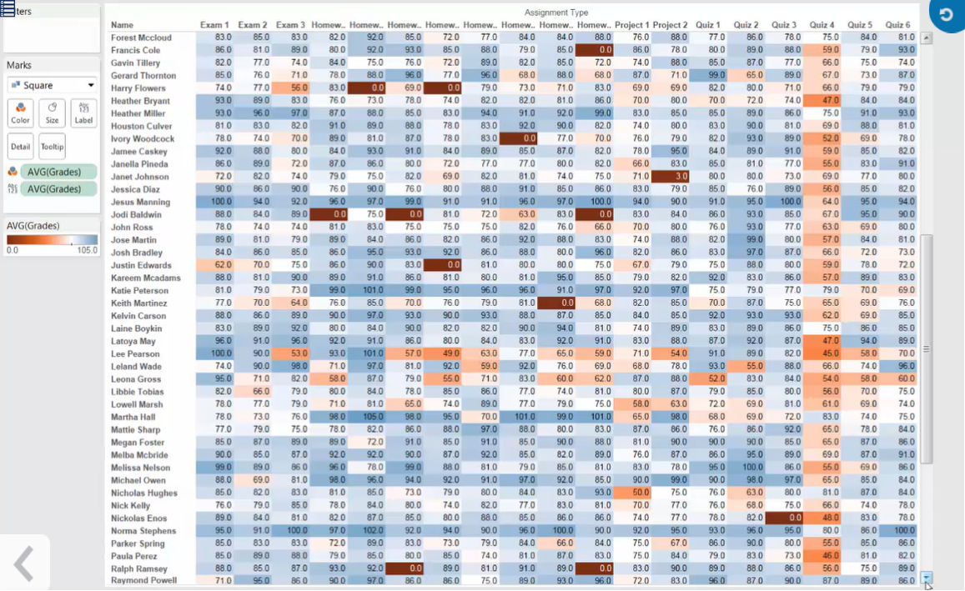

Connect Tableau to the *Sample – Superstore.xlsx* file. Select the *Orders* worksheet. Then go to *Sheet 1.*

Step 1: Drag the measure that you want to display to the *Label* button in the *Marks* card. In this case, we want to drag *Sales* to the *Label* button (you can also drag it to the work area of your visualization). We will get one number that is the sum of *Sales*. Your document should look like this:

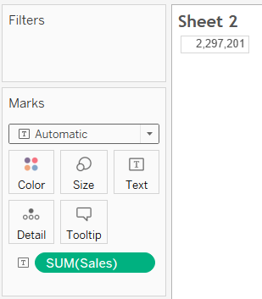

Step 2: Drag *Region* to the *Columns* shelf. Drag *Category* and *Sub-Category* to the *Rows* shelf. Your document should look like this:

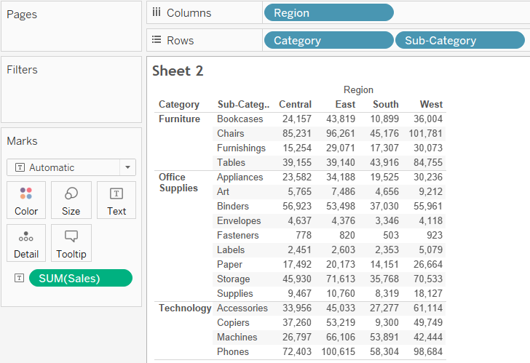

Step 3: Drag *Sales* (from the *Data* column on the left) to the *Color* button on the *Marks* card. This will color-code the *Sales* values (your colors may vary). Your document should look like this:

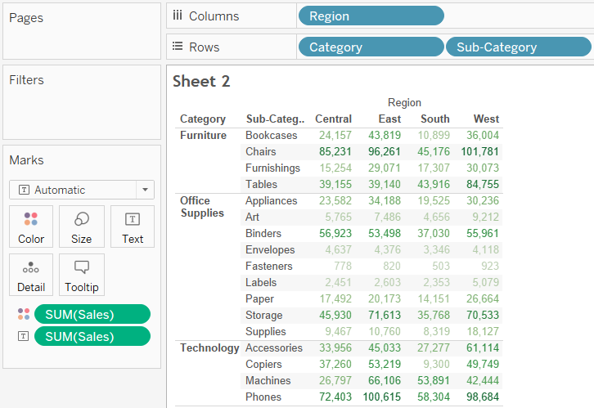

Step 4: In the drop-down box on the *Marks* card, change from *Automatic* to *Square.*

This will fill in the background of each cell. Your document should look like this:

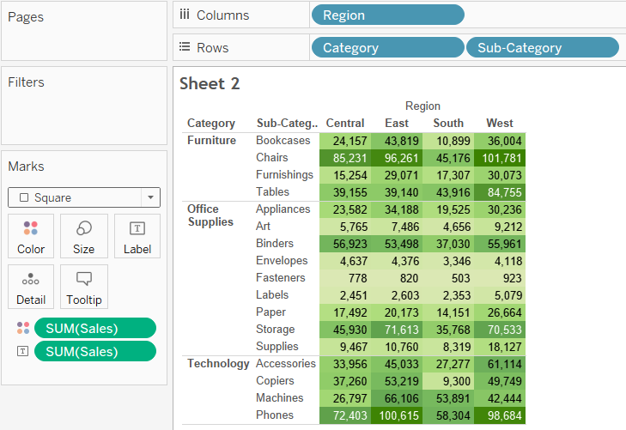

Step 5: Let's change the colors that we use. I want the low numbers and the high numbers to stand out. In the *Sales* legend on the right side, click on its down-arrow.

Then click on *Edit Colors*. Click on the *Palette* drop down box. Click on *Red Green Diverging*.

Turn on *Stepped Color* and set the number of steps to 4.

Your document should look like this:

Step 6: Add grid lines. Right-click on any of the numbers in the table and click on *Format….*

On the left side, click on the *Borders* icon:

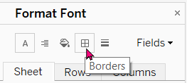

Click on the *Sheet* tab. Under *Default*, click on the down-arrow next to *Cell* and select the width, style, and color of your cell borders. Your document should now look something like this:

# Heat Maps

Wikipedia [definition](https://en.wikipedia.org/wiki/Heat_map) of a heat map (sounds like Tableau's *Highlight Table* [above]).

Heat map example: [Gas Buddy](https://www.gasbuddy.com/GasPriceMap)

Tableau definition of a heat map (a little different): A table that compares two (or one—but then it's a highlight table) measures using color for one measure and size for the other measure.

To create a heat map, we will again use the *Sample - Superstore.xlsx.* Click on the *New Worksheet* button to create a new worksheet, *Sheet 2*.

Step 1: Drag *Sales* to the *Marks Size* card.

Step 2: Drag *Profit* to the *Marks Color* card.

Step 3: Drag *Category* to the *Rows* shelf.

Step 4: Drag *Sub-Category* to the right end of the *Rows* shelf.

Step 5: Drag *Region* to the *Columns* shelf. Your document should look like this:

## Improve the readability.

Step 6: Click on the drop-down arrow on the *SUM(Profit)* legend and choose *Edit Colors…*.

Step 7: On the *Edit Colors (Profit)* dialog box, click on the down arrow below *Palette*. Click on the *Orange-Blue Diverging* palette. NOTE: This is a good color combination because even people who are colorblind can see these colors.

Step 8: Turn on the *Stepped Color* check box, and set the number of steps to 6. Your dialog box should look like this:

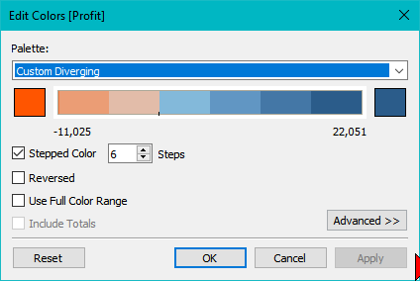

Step 9: Increase the size of the *Sales* squares. In the legend area, click on the down-arrow next to *SUM(Sales)* click on *Edit Sizes…*

Step 10: Drag the slider to make the marks bigger. Don't make them so big that they overlap.

Click on *OK.* Your document should look something like this:

# Adding Gridlines

Right-click on a value in the crosstab. Click on *Format*.

Click on the *Borders* icon at the top.

Click on the *Rows* tab to change the style, width, and color of the grid lines.

# Adding Totals and Subtotals.

Row totals: Open the *Analysis* menu. Click on *Totals*. Click on *Show Row Grand Totals*.

Column totals: Open the *Analysis* menu. Click on *Totals*. Click on *Show Column Grand Totals*.

Subtotals: Open the *Analysis* menu. Click on *Totals*. Click on *Add All Subtotals*. This adds totals to each pane in the table.

By default, Tableau creates a sum. To switch the aggregation type to average, click the drop-down arrow on Sales in the *Marks* area. Click on *Measure*. Select *Average*. Note that there are other aggregation types as well.

Changing the labels from *Total* to *Average*: Right-click on the word *Total* in the crosstab*.* It occurs 3 times; you can click on any one of the 3. Click on *Format*.

Click on the *Header* tab.

Click on the *Label* box and replace "Title" with "Average". Your table should now look like this:

