Tableau Histograms

What is a histogram? From Wikipedia:

A **histogram** is an accurate representation of the [distribution](https://en.wikipedia.org/wiki/Frequency_distribution) of numerical data. It is an estimate of the [probability distribution](https://en.wikipedia.org/wiki/Probability_distribution) of a [continuous variable](https://en.wikipedia.org/wiki/Continuous_variable) and was first introduced by Karl Pearson.[[1]](https://en.wikipedia.org/wiki/Histogram#cite_note-pearson-1) It differs from a [bar graph](https://en.wikipedia.org/wiki/Bar_graph), in the sense that a bar graph relates two variables, but **a histogram relates only one**. To construct a histogram, the first step is to "[bin](https://en.wikipedia.org/wiki/Data_binning)" (or "[bucket](https://en.wikipedia.org/wiki/Data_binning)") the range of values—that is, divide the entire range of values into a series of intervals—and then count how many values fall into each interval. The bins are usually specified as consecutive, non-overlapping [intervals](https://en.wikipedia.org/wiki/Interval_(mathematics)) of a variable. The bins (intervals) must be adjacent, and are often (but not required to be) of equal size.

#### Examples of histograms

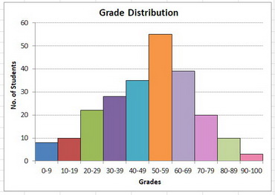

Connect to *Math Scores.xlsx.*

Click on the *College Math Scores* field.

Click on *Show Me* and select *histogram.*

Your chart should look like this:

In the *Tables* group on the left, click on the down-arrow next to *College Math Scores (Bin).* Click on *Edit*:

Set the *Size of Bins* to 50 and click on *OK*.

Turn on labels (click on the "T" icon—*Show Mark Labels*—on the toolbar).

A label will appear above each bar.

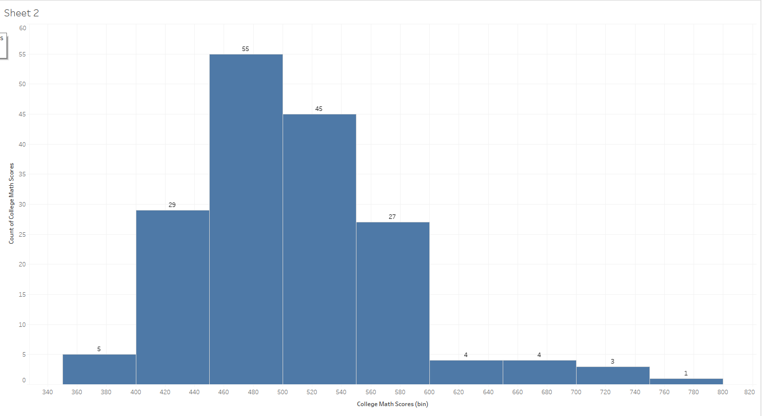

### Change the labels to percentages.

Click on the down-arrow on the *CNT(College Math Scores)* pill on the *Rows* shelf. Click on *Quick Table Calculations*. Click on *Percent of Total:*

The labels will change to percentages:

### Add a running sum

Drag *College Math Scores* to the *Rows* shelf. Click on its down-arrow. Click on *Measure*. Click on *Count:*

A second histogram will appear at the bottom:

Click on the down-arrow of the second *CNT(College Math Scores)* pill on the *Rows* shelf. Click on *Quick Table Calculation*. Click on *Running Total*:

Running totals will now appear.

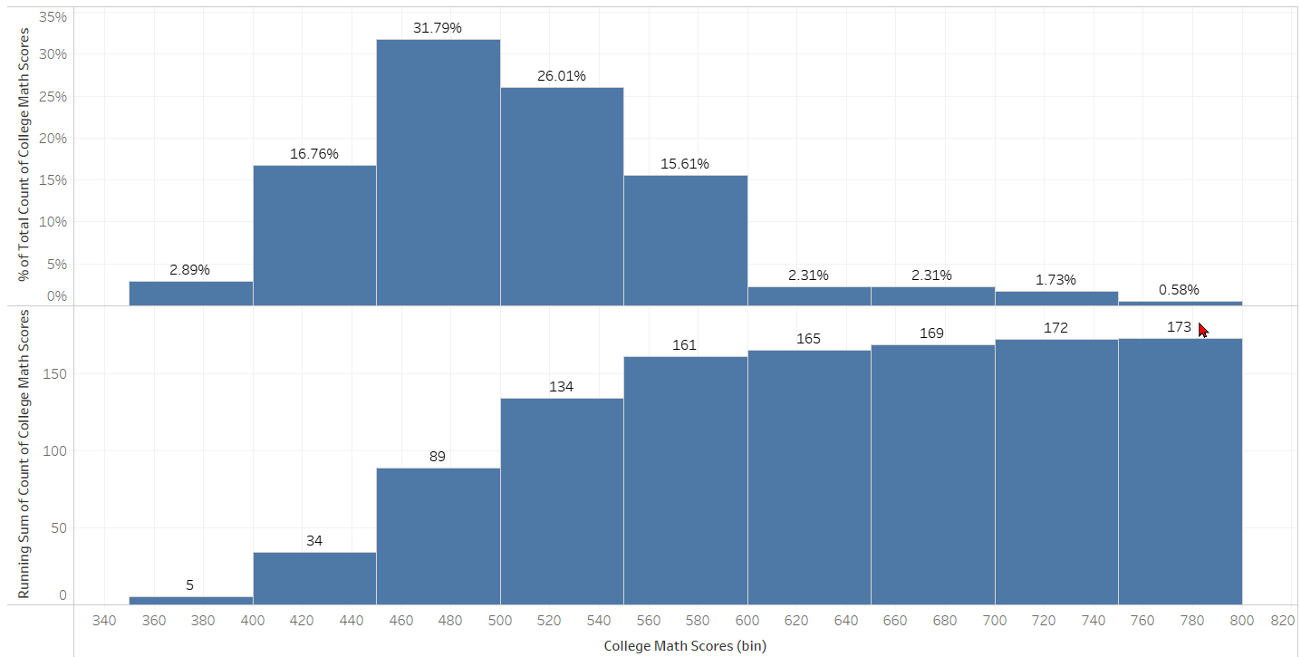

Click on the down-arrow of the second *CNT(College Math Scores)* pill on the *Rows* shelf. Click on *Edit Table Calculation:*

Click on the *Add Secondary Calculation* check box. Click on the down-arrow under *Secondary Calculation Type*. Click on *Percent of Total*:

Click on the "X" to close the dialog box. Your chart should look like this:

### Change to a line

Right-click to the left of the y-axis of the bottom chart.

Click on *Mark Type*.

Click on *Line*. It will change to a line.

### Combine the charts

Again, right-click to the left of the y-axis of the bottom chart.

Click on *Dual Axis*.

The charts will be combined:

Now you can make some changes in the histogram by right-clicking on the left y-axis and on the line chart by right-clicking on the right y-axis.

### Allow an end user to change bin size

Under *Tables*, click on the down-arrow of *College Math Scores (bin)*.

Click on *Edit…*

Under *Size of Bins*, you can change the size of the bins.

Click on the down-arrow in the *Size of Bins* check box. Click on *Create a new parameter…*

For the parameter *Name*, enter *Bin Size.*

At the bottom left of the dialog box, set the *Minimum* to 10*, Maximum* to 200*,* and *Step Size* to 10*.*

Click on *OK.* Click on *OK*.

The parameter will appear on the right side of the chart. If it doesn't appear, click on the down-arrow next to the *BinSize* parameter and click on *Show Parameter:*

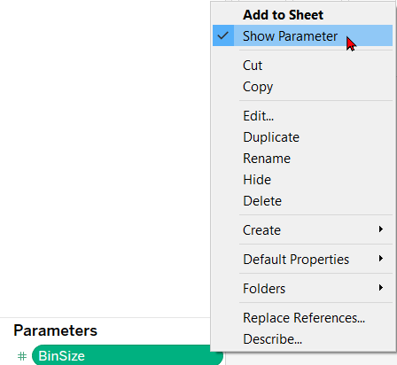

Click on the down-arrow next to the parameter (on the right side). Click on *Slider*.

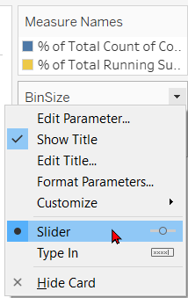

A slider will appear below the *BinSize* parameter:

