Tableau #5: Grouping data, dates/times

Connect to the *Superstore2016.xlsx* file.

## Grouping data

Drag *Sub-Category* to the *Rows* shelf.

Drag *Sales* to the *Columns* shelf.

Sort in descending order. This will put *Envelopes, Fasteners*, and *Labels* at the bottom.

Click on the *Envelopes* label along the y-axis, then ctrl+click on *Fasteners* and *Labels* (also along the y-axis) to select all three. NOTE: You can click on the bars or the labels; it doesn't matter.

Right-click on your selection. Click on *Group*.

A label that says *Envelopes, Fasteners, Labels* will appear and the bars will be combined. However, for some reason, Tableau thinks it needs to re-sort the data by sub-category name, and not on the sales value. Re-sort by clicking on the *Sort Descending* button on the toolbar:



The bars should be sorted again:

Right-click on *Envelopes, Fasteners, Labels* (along the y-axis). Click on *Edit Alias*….

Enter *Desk Supplies* for the name.

The label will change to *Desk Supplies* and the blue pill in the *Rows* area now says *Sub-Category (group)*:

## Creating visual groups

Go to a new worksheet. Drag *Sub-Category* to the *Rows* shelf.

Drag *Sales* to the *Columns* shelf.

Sort in descending order. This will put *Envelopes, Fasteners*, and *Labels* at the bottom.

Click on the *Envelopes* bar on the chart. Ctrl-Click on the *Fasteners* and *Labels* bars (not the text). Right-click and choose *Group*. They will turn blue and the rest of the bars will become gray.

Click on the *Copiers* bar on the chart. Ctrl-click on the *Appliances* bar and the *Machines* bar.

They will turn orange.

At the bottom of the *Dimensions* area, right-click on *Sub-Category (group1)*. Then click on *Edit Group*.

In the *Field Name* box, type *Office Products*.

In the legend, right-click on *Appliances, Copiers, Machines.* Click on *Edit Alias…* Type *Office Machines* over the existing text. Press *Enter.*

The label in the legend will change to *Office Machines*.

Do the same for *Envelopes, Fasteners, Labels* in the legend. Right-click on it. From the popup menu, click on *Edit Alias…*

In the *Edit Alias* window, type *Desk Supplies* over the existing text.

Click on *OK*. The legend will now have the blue and orange bars identified:

## Hierarchies

A *hierarchy* groups several related dimensions together.

Click on *Category* and then ctrl-click on *Sub-Category* to select both of them.

Right-click on either one of the selected dimensions.

Click on *Hierarchy*. Then click on *Create Hierarchy*.

Name the hierarchy *Products*.

Click on OK.

To add another dimension to the *Products* hierarchy, right-click on *Product Name*. Click on *Hierarchy*. Then click on *Add to Hierarchy*. Then click on *Products*. The *Product Name* field will be added to the *Products* hierarchy.

Your *Products* hierarchy will now look like this:

## Create a chart using the *Products* hierarchy

Start a new worksheet.

Drag *Sales* to the *Columns* shelf.

Drag the *Products* hierarchy to the *Rows* shelf. Note that it is labeled *Category*.

You will get a bar chart with one bar for each category:

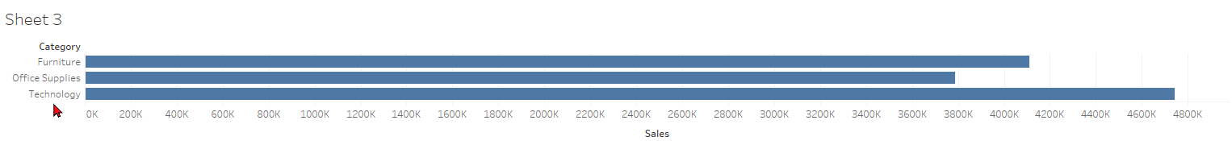

Move the mouse over the word *Category* at the top of the y-axis. The following should appear: a plus sign, an A-Z sort button, and a down-arrow.

Click on the plus sign to reveal the next level in the hierarchy, *Sub-Category*:

Move the mouse over *Sub-Category* and click on the plus sign.

The third level in the hierarchy (*Product Name*) will appear:

Date Fields: discrete and continuous

# Continuous Fields

Use a continuous date field when you want to visualize data over time.

Create a new worksheet.

Drag *Sales* to the *Rows* shelf.

Drag *Order Date* to the *Columns* shelf. By default, Tableau chooses the largest date unit (Years) and makes a discrete field. We can tell that it is discrete because it is blue.

Let's change it to a continuous field. Click on its down-arrow. The continuous date fields (green) are below the bar, and the discrete date fields (blue) are above the bar. NOTE: there is no difference between a continuous *Year* field and a discrete *Year* field (try it). Let's change it to a continuous *Quarter* field. Click on *Quarter Q2 2015*.

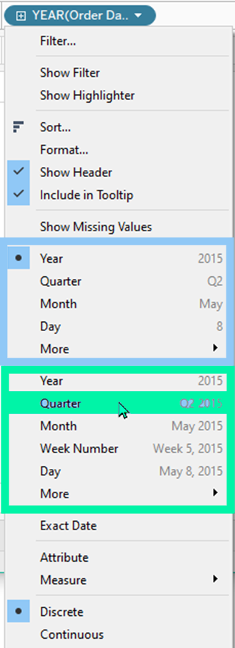

Your result should look like this:

It shows each quarter that we have data for.

Now let's change *Quarter* to *Month* (continuous). On the *Columns* shelf, click on the down-arrow next to the *QUARTER(Order Date)* pill. Click on *Month May 2015*. This will show each month's sales for each month that we have data for.

Your chart should look like this:

Change to *Week Number Week 5 2015*:

Your chart should look like this:

Then change to *Day May 8, 2015*.

Your chart should look like this:

This is obviously too much data.

# Discrete Fields

## Discrete Year

Now let's try some discrete fields. On the *Columns* shelf, on the *Day(Order Date)* pill, click its down-arrow. Click on *Year 2015* (the first, discrete, occurrence). Your chart will look like this (which is exactly the same as *Year 2015* (the second, continuous, occurrence), so it will look exactly the same:

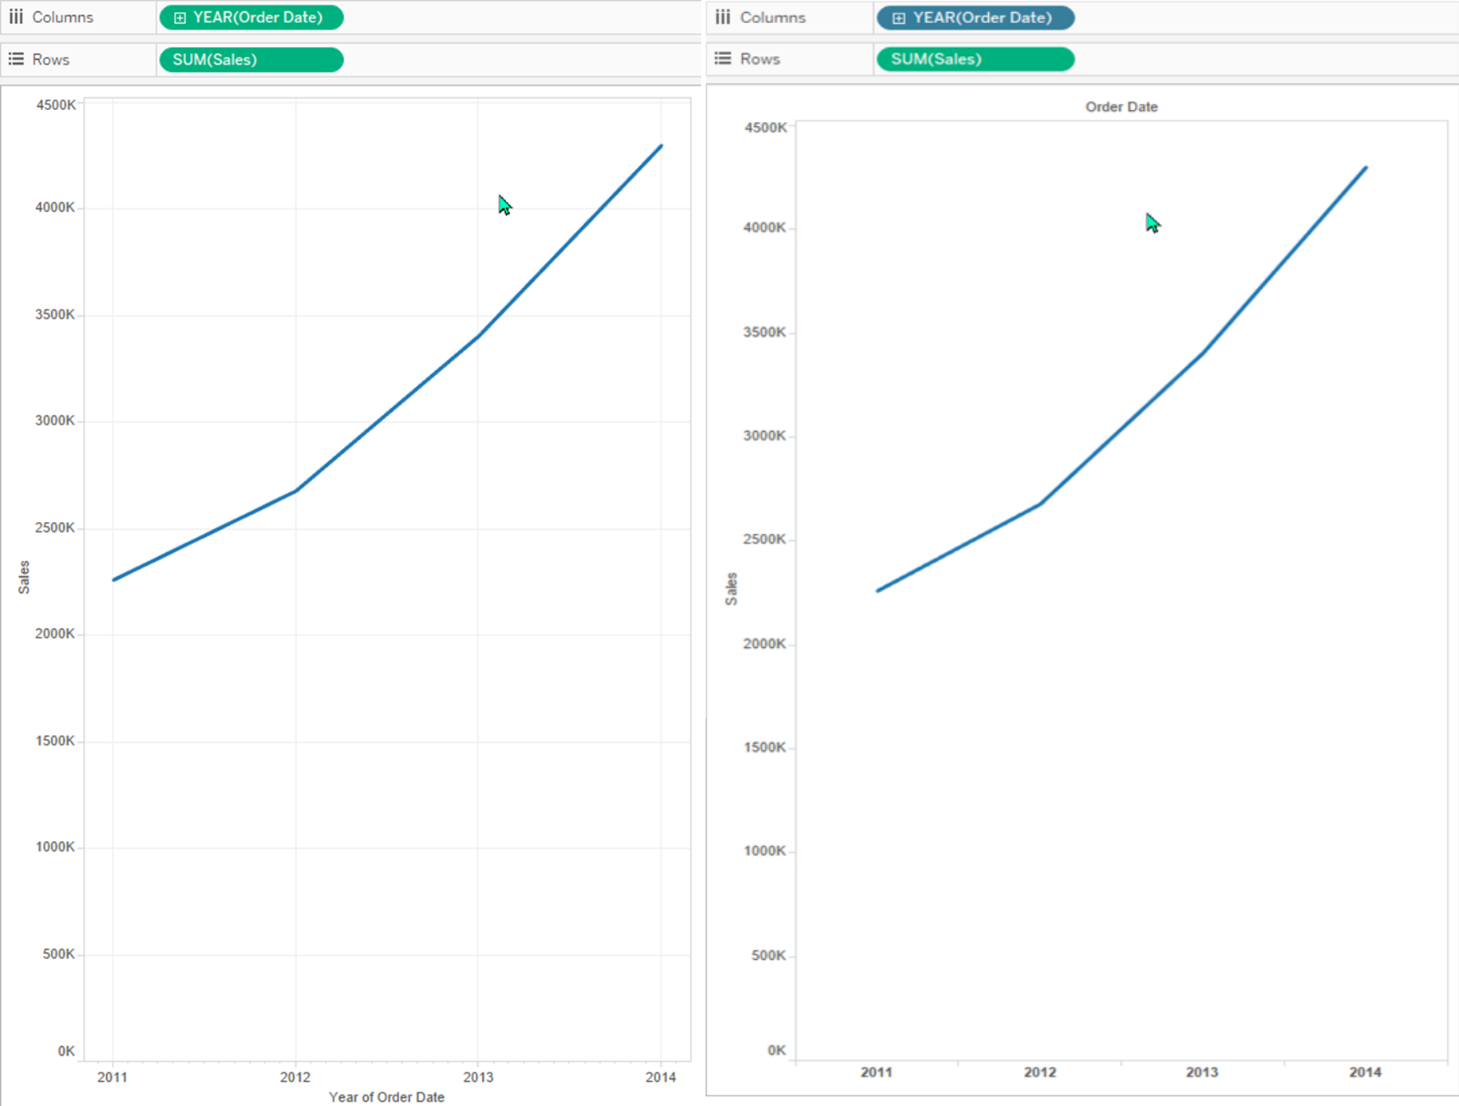

## Discrete Quarter

Now click on the down-arrow next to YEAR(Order Date) and click on *Quarter Q2* (it is the first occurrence of *Quarter*).

Tableau will now group quarters together, so all of Q1 will be added, all of Q2 will be added, etc., which means we will only have 4 values on the x-axis: Q1 through Q4. Your chart will now look like this:

Or, if you change the chart type to bar (on the down-arrow in the *Marks* group) where it will probably be easier to estimate the actual numbers:

It will look like this:

## Discrete Month

In the *Columns* shelf, on the *QUARTER(Order Date)* pill, click on the down-arrow and click on *Month May*:

Your chart will look like this:

## Discrete Day

We can also do discrete days, although it isn't very useful. In the *Columns* shelf, on the *Day(Order Date)* pill, click on the down-arrow and click on *Month May.*

Your chart will look like this:

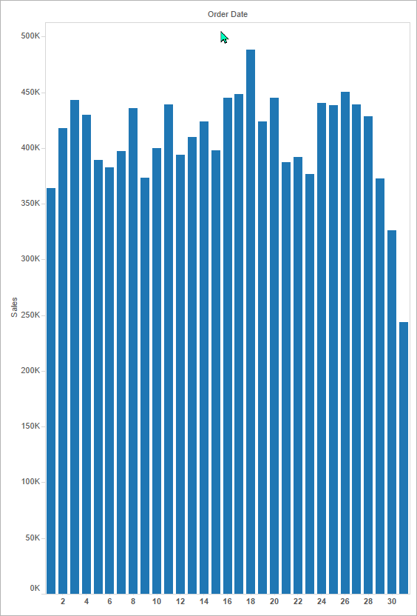

This refers to a number from 1-31, not from 1-365, and isn't very meaningful.

## Discrete Week Number

We can also get discrete week numbers (1-52). Click on the *MONTH(Order Date)* drop-down box. Click on *More*. Click on *Week Number*:

This gives us 53 values, one for each week of the year:

## Discrete Weekday

We also can see how our sales are based on the seven days of the week. From the *WEEK (Order Date)* pill on the *Columns* shelf, click on the down-arrow, click on *More*, then click on *Weekday*:

This gives us 7 values:

