Tableau Day #3: Table Calculations

## Table Calculations

Table calculations are calculations that are performed in Tableau on the result set that is returned from your database. The calculations are performed on the data that you see on the screen.

### Percent of Total example

Open the *Superstore Orders 2016.xlsx* spreadsheet.

Drag *Order Date* to the columns shelf.

In the pane, hover the mouse over the *2012*. Click on the plus sign. It will change to a minus sign and quarters will appear:



Hover the mouse over the *Q1* for year 2012. Click on the plus sign. It will change to a minus sign and months will appear:

Hover the mouse over the *January* for the year 2012. Click on the plus sign. It will change to a minus sign and days will appear:

#### Another way:

Click the down-arrow on the *Year (Order Date)* pill on the *Columns* shelf.

Above the line:

You will see *Year, Quarter, Month, Day, More* both above and below a divider line. The selections above the line will group all 1st Quarter items together (for all years), all 2nd Quarter items together (for all years), etc. It will do the same for Month, and Day.

Below the line:

* Year: will group data into one bin per year.
* Quarter: will have 4 bins for each year.
* Month: will have 12 bins for each year.

Select Year from the top group (as shown above). Your screen will look like this:

Drag Region and Segment to the rows shelf.

Drag *Sales* to the data area.

Your sheet will look like this:

Add grand totals:

* Click on: Analysis | Totals | Show Row Grand Totals

* Click on: Analysis | Totals | Show Column Grand Totals

Add subtotals:

* Click on: Analysis | Totals | Add all subtotals

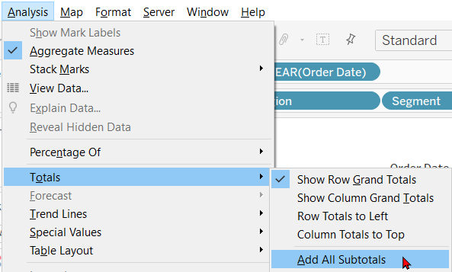

Your worksheet will now look like this:

On the green SUM pill in the *Marks* box, click on the down-arrow. Click on *Quick table Calculations | Percent of Total.*

Your worksheet will now look like this:

Each number will be represented as a percent of the total. NOTE that the percentages are for rows, not columns. We know this because 100% is on the right side of each row.

Note also that the dollar values are gone and have been replaced by percentages. If you want to see both the dollar values and the percentages, you need to drag *Sales* to the work area (a second time). We will use one of the *Sales* pills for the dollar values and the other for the percentages. Your worksheet will now look like this:

On the top green SUM pill in the *Marks* box, click on the down-arrow. Click on *Edit table Calculation*.

The *Table Calculation* window will appear.

Try the different options:

1. **Table (across)**: makes every ROW in the table 100% (100% will occur on the right end of every row).
2. **Table (down)**: makes every COLUMN in the table 100% (100% will occur at the bottom of every column).
3. **Table**: Makes the whole table 100% (100% will occur once at the bottom of the last column and the right side of the bottom row).
4. **Pane (across)**: same as *Table (across*).
5. **Pane (down)**: makes each vertical pane (group) add to 100%.
6. **Pane**: makes every pane (rectangle) add to 100%.

To have a Pane (across) option, we would have to have more than one pane going across the table. We can get this by adding **Ship Mode** to the *Columns* shelf.

#### Rank Example

Create a new worksheet.

Drag *Order Date* (Year) to the columns shelf.

Drag *Sales* to the work area. Do not drop it until you see the rectangle around the Abc's:

It should look like this:

Click on the down-arrow on the right side of the SUM pill. Choose *Quick Table Calculation* and then click on *Rank*:

The years will be ranked from 1-4:

If you also want to see the sales values (which you probably do), drag *Sales* to the work area (note that you must drop it on the rectangle again—the picture below is just below the rectangle):

It should look like this:

If you would like to sort the data in rank order, click on the *Swap Rows and Columns* (transpose) button:



You should get this:

If you click on the *Sort Ascending* button, the *Sales* column will be sorted by default (and we want it the other way around). Although we could just click on the *Sort Descending* button, let's make Tableau sort using the *Rank* column as the key field. Pause the mouse over the *Rank of…* column and click on it when the blue tab appears in the upper-left corner. Click on the *Sort Descending* button.

Your result should be:

Drag *Category* to the right end of the *Rows* shelf. Your table now looks like this:

It is now ranking *all* of the *Sales* numbers in order from 1-12.

If you would rather have each category ranked from 1-4, drag *Category* from the *Rows* shelf to the *Columns* shelf.

Click on the down-arrow next to the green SUM(Sales) button. Click on *Edit Table Calculation*. In the **Compute Using** box, try the different options.