Getting started with Tableau
Open Tableau.

The Tableau interface
The Tableau interface has 10 parts:
- Data sources
- Dimensions and Measures. Dimensions are categories, usually text fields, but they can also be numeric fields that are meant to classify, not to be summed (e.g. ZIP code, job classification, etc.). They are BLUE. Measures are numbers that can have functions applied to them: SUM, AVERAGE, MIN, MAX, etc. They are GREEN.
- The Show Me "card".
- The Columns and Rows "shelves". Tableau has a column "shelf" and a row "shelf". These are similar to the row and column areas in an Excel pivot table.
- The Marks "card". Controls color, size, label text, tooltip text, and shape.
- The Filters shelf.
- The Pages shelf: filters the visualization by stepping or animating based on a particular field.
- The view area (the drawing canvas).
- Sheets and Dashboard tabs.
- The session tabs: connect to data, show all tabs in a worksheet, or see all workbooks for a user.

Example 1: Summing
Under Connect, under To a File, click on Microsoft Excel.
Find NYCTrash.xlsx and open it. This is the garbage collection data for the city of New York for September, 2011. Examine the data. Each borough is divided into Community Districts.
We want to compare the collection numbers for each of the 5 boroughs.
Drag the Borough field to the Rows shelf. We get a list of the 5 boroughs.
Drag the Refuse Tons Collected to the Columns shelf. We get a bar chart, with one bar per borough.
There are other ways to represent this data:
Go to Show Me and pause the mouse over the first option, Text Table (the name of the visualization appears at the bottom of the Show Me window).
Try the following:
- Heat map
- Highlight tables
- Pie Chart (you will have to skip over two that are grayed out). Note that the legend for the pie chart is behind the Show Me window.
- Horizontal bars. NOTE: to get a column chart (vertical bars), you must move Borough to the Columns shelf and SUM(Refuse Tons…) to the Rows shelf.
- Stacked bars
- Tree map
- Circle view
- Box-and-whisker
- Packed bubbles
Which view makes the most sense? Probably Bar or Column chart.
Note that the data is sorted in alphabetical order based on the name of the borough.
Let's sort it by the length of the bar. Click on the Sort Descending button on the toolbar:
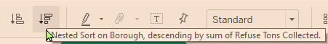
Our chart is now sorted:
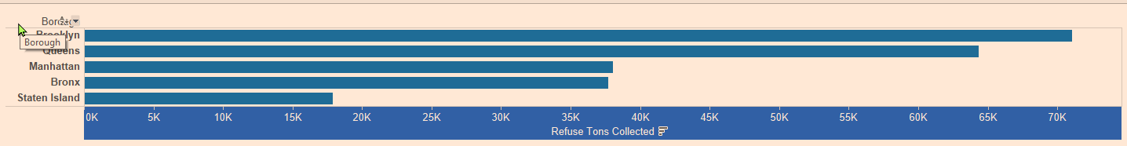
To learn more about how Tableau is sorting its data, click on the right side of the Borough pill:

From the menu, click on Sort….
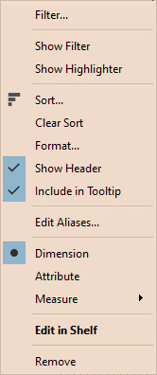
The following will appear:
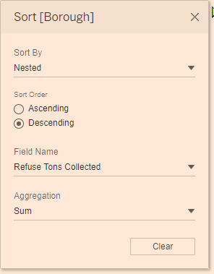
Swap the labels and the values by clicking on the Swap button on the toolbar:
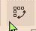

Grid Lines
Let's add grid lines. To add grid lines, right-click on the chart background, and choose Format. The Format box will appear on the left.
Click on the Lines button:
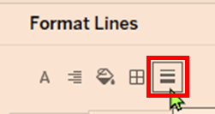
Click on the Rows tab. Click on the down-arrow button on the Grid Lines box and choose a solid line, choose a thin line, and select a color.

Example 2: Counting
Connect to the file NYCRatSightings.xlsx by doing the following:
Click on the Tableau button on the far left end of the tool bar.
Click on Connect. Then click on Microsoft Excel. Locate NYCRatSightings.xlsx. Click on the New Worksheet button on the bottom left of the window.
Drag the Rat_Sightings(Count) field to the center of the display area (below Rows and Columns shelves and to the right of the Marks card).
The number 35,655 should appear in the data area. Note that the green pill says "CNT(Rat_Sightings)". It is computing the COUNT of the number of records.
Drag the Boroughs field to the Rows shelf. You will get a table:
Replace Borough with City on the Rows shelf. You will see a list of city names. Sort in ascending order. Note that there is an entry for BROOLKYN (misspelling of Brooklyn):
Drag "CNT(Rat_Sightings)" off of the Marks card. Right-click on the Unique Key field and drag it to the Columns shelf. When you let go of the mouse, the following will appear:
When you right-click and drag a field to a shelf, you will get this list of functions to choose from. Choose CNT(Unique Key) as indicated above and click on OK. When I do this, I get a bar chart, with a lot of very short bars, and a few very long bars. Let's sort the bars by clicking on the Sort Descending button on the toolbar
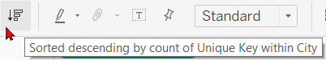
Click on Show Me and choose Text Table. When you do this, the CNT(Unique Key) pill moves from the Columns shelf to the Marks card.
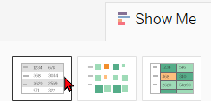
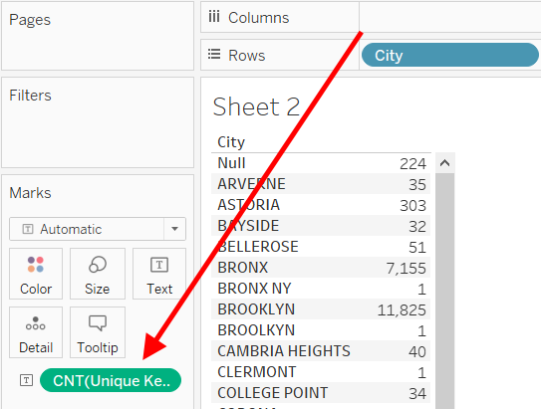
Replace City with Borough on the Rows shelf.

Example 3
Connect to the Global Superstore Orders 2016.xlsx. Drag the Orders table (there is also a People table—ignore it) to the blank area on the right. 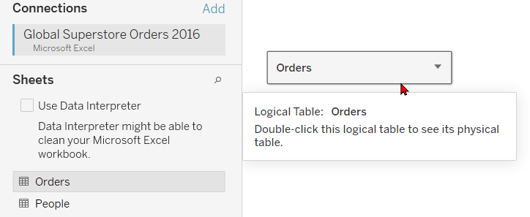
Click on the New Worksheet button on the bottom left.
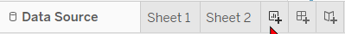
In Tableau:
- Drag the profit field to the middle of the Tableau work area.
The total profit will appear as a text value.
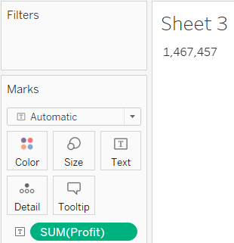
- Drag it (the green "pill") back again.
- Drag the market field to the middle of the Tableau work area.
A table listing the unique market values will appear.
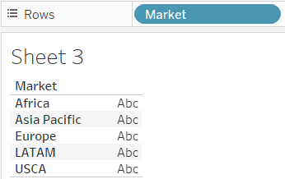
Drag it back again.
- Drag profit to the rows shelf. You get a vertical bar representing the total profit.
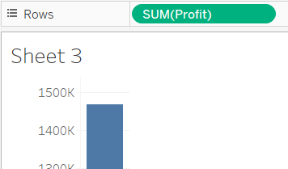
- Drag profit to the columns shelf. You get a horizontal bar representing the total profit.
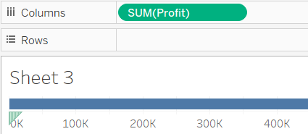
- Drag market to the rows shelf. You will get a horizontal bar chart.
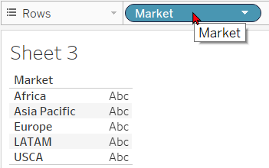
- Move market to the columns shelf and profit to the rows shelf. You will get a column chart.
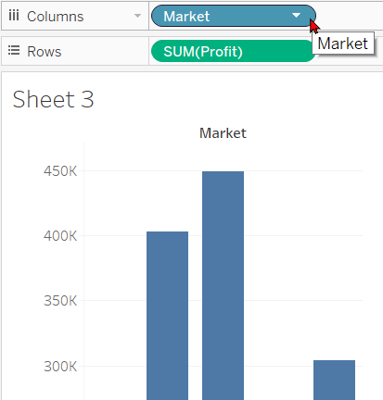
- Drag segment to the columns shelf. Our data is now broken down by market and then by segment.
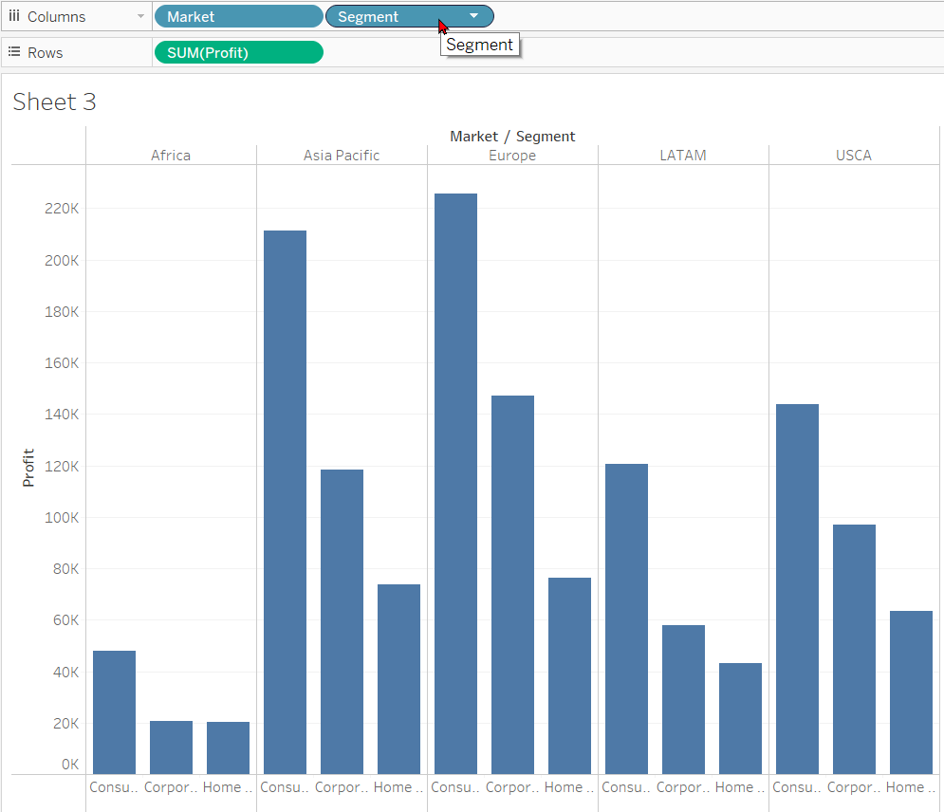
- Drag market (from the Tables area on the left, not from the Columns shelf) to the Color Card.
Each market is now a different color.
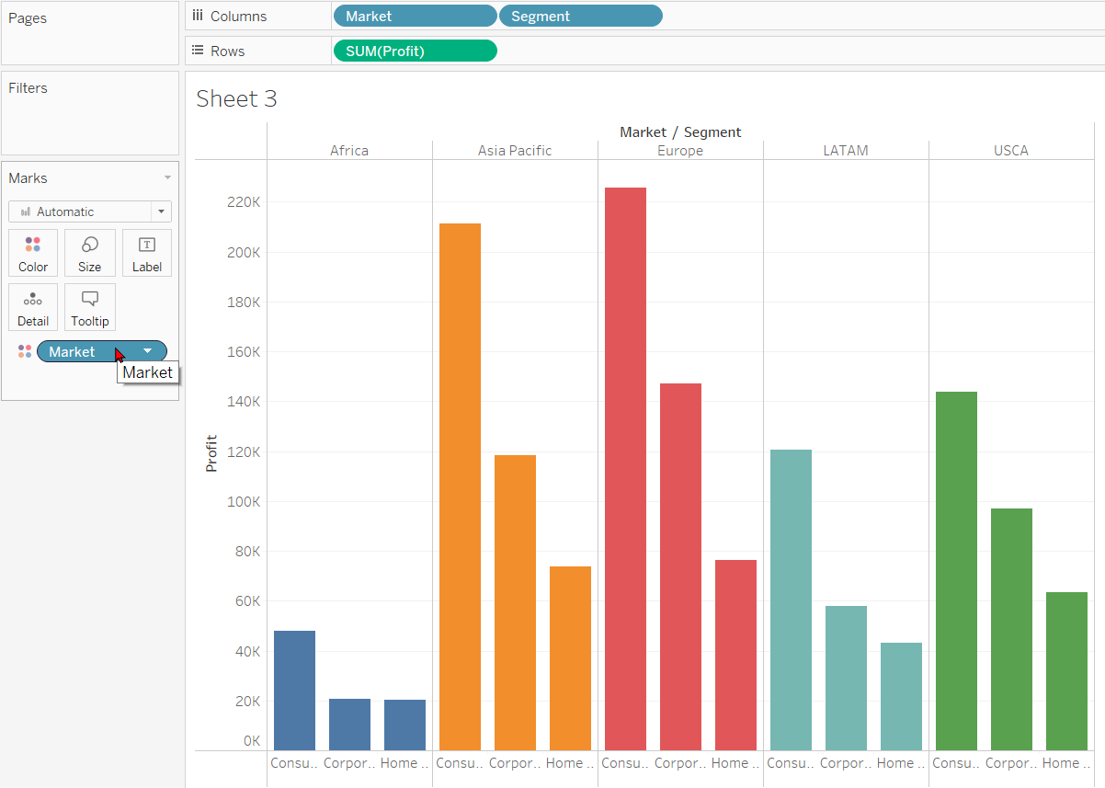

Note that this isn't very useful because they are already grouped by Market. But change the grouping by putting Segment before Market on the Columns shelf. Now it looks like this:
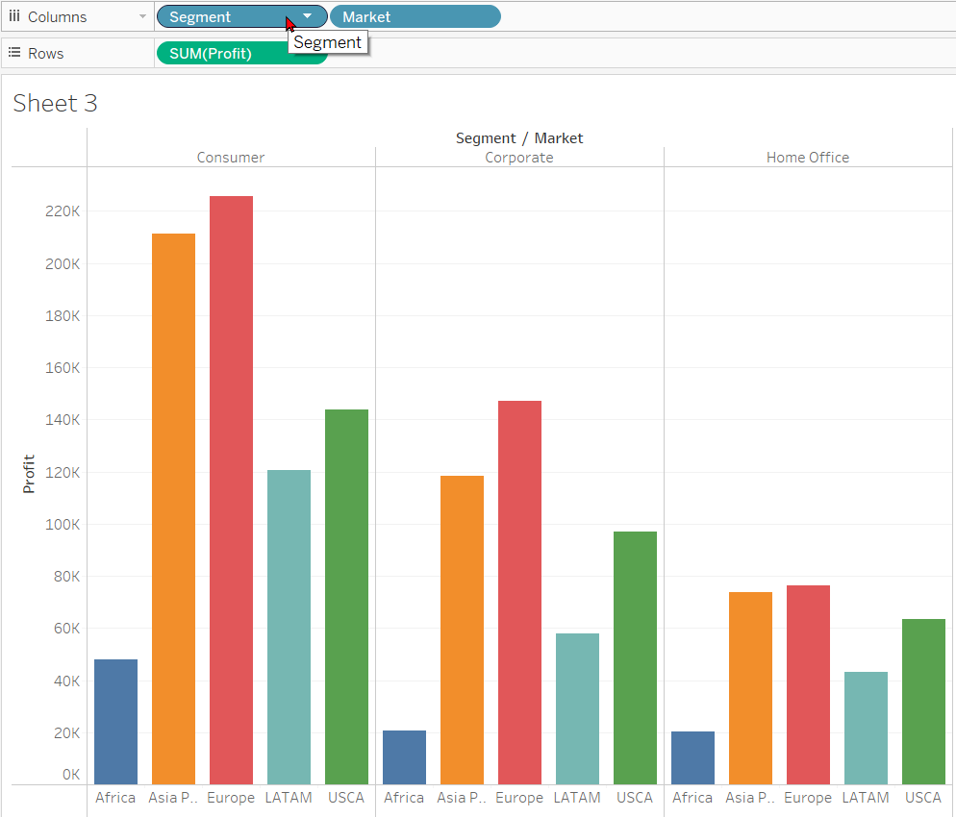
- Reverse Segment and Market on the Columns shelf so that Market is again to the left of Segment. Drag segment to the Color card. It now looks like this:
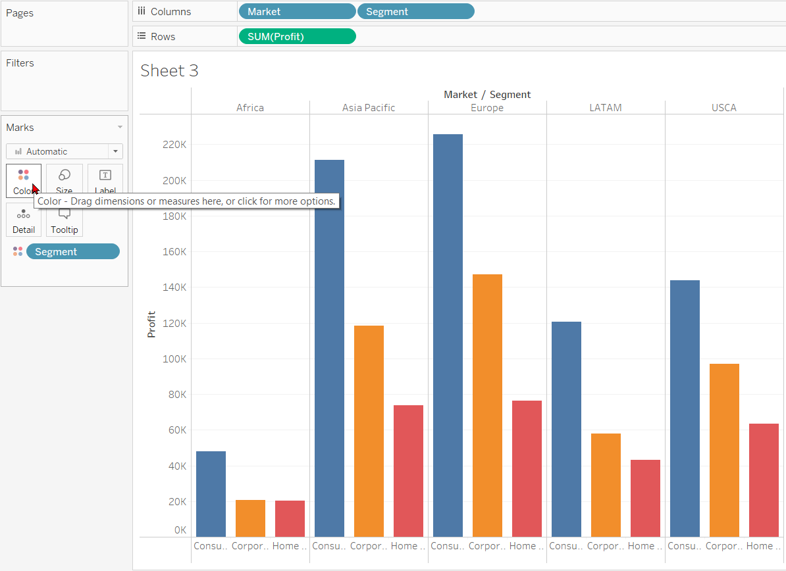

- Drag Segment (from the Tables area, not from the Marks area) to the Label card. It adds the name of the segment to the top of the bar.
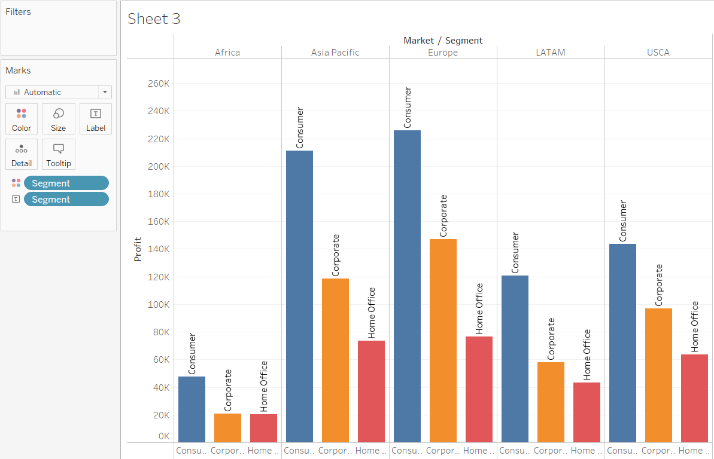
This is not what we want. Remove Segment from the Label card.
- Drag Profit to the Label card. It adds the amount of profit to the top of the bar.
- 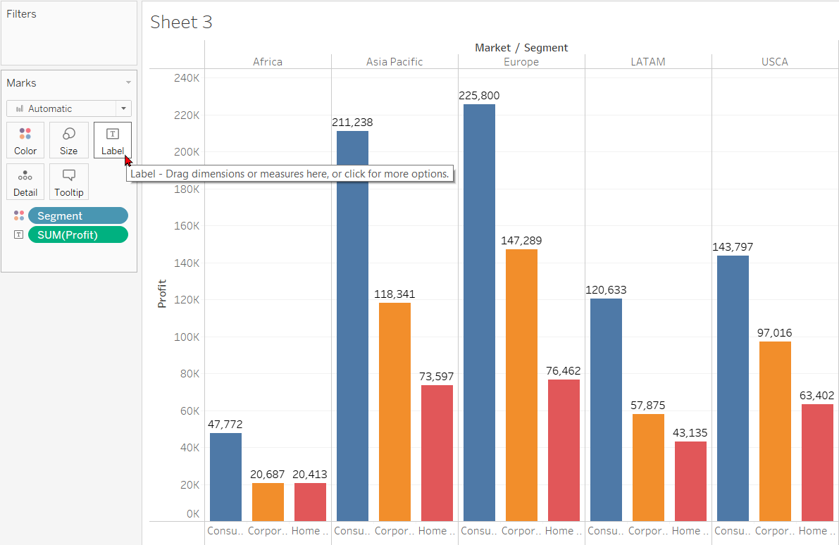
You can convert this into a horizontal bar chart if you flip-flop the pills on the Rows and Columns shelves:
