Tableau Dashboard Action

# Use Tableau to connect to the *Data-World-Bank-CO2.xlsx* file.

# Data Visualization 1

Create the following visualization.

Each country has its total CO2 emissions represented by a colored dot. The amount of CO2 is represented both by the size of the dot and the color. There are 9 colors. The year field is used as a filter and currently is showing the year 2014.

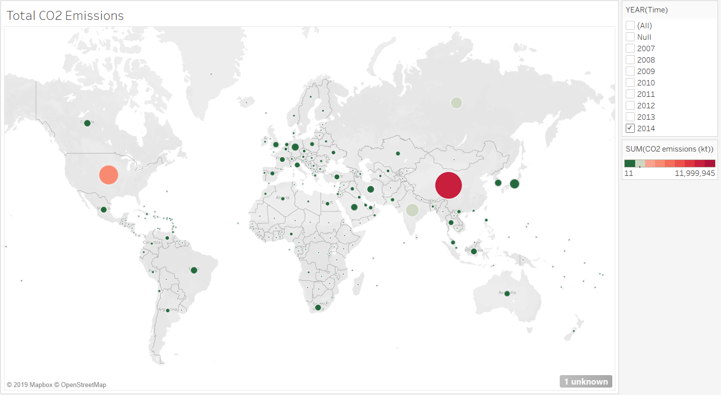

# Data Visualization 2

This is almost identical to the previous visualization, but uses the CO2 Per Capita column.

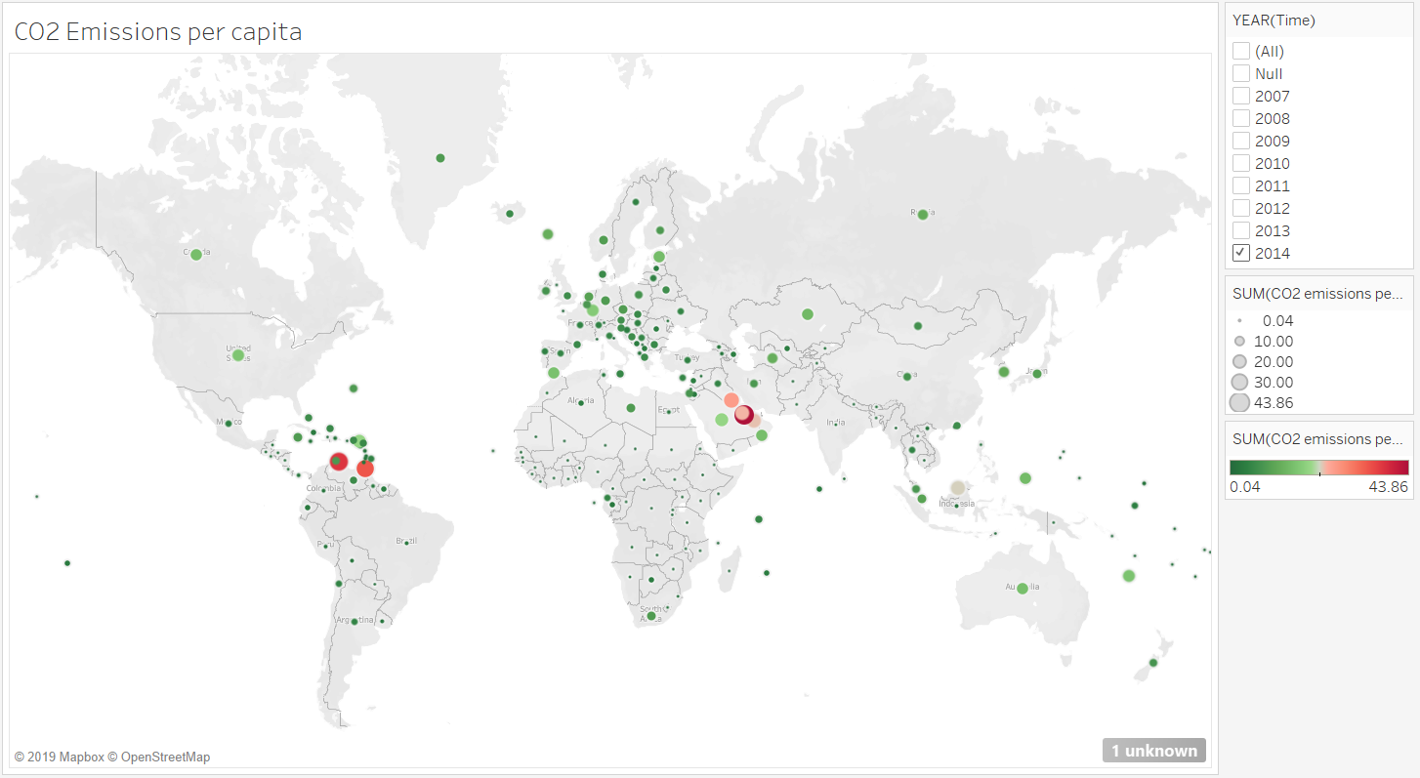

# Data Visualization 3.

The following has years along the x-axis, and each line represents the CO2 Per Capita value for a different country. Lines are colored by country.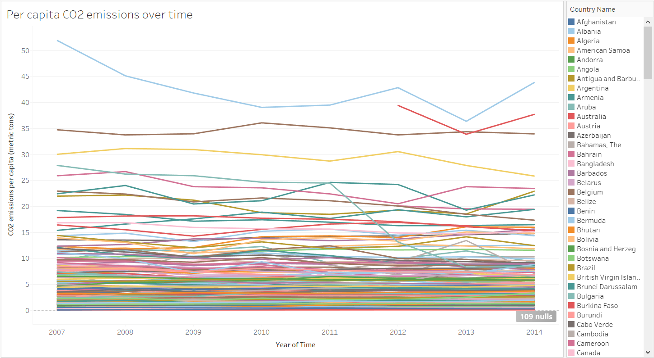

# Dashboard with actions

Use the above worksheets to create the following dashboard. It has the following actions.

1. Filter: When the user clicks on a line in the line chart, the corresponding country is selected on the two maps.

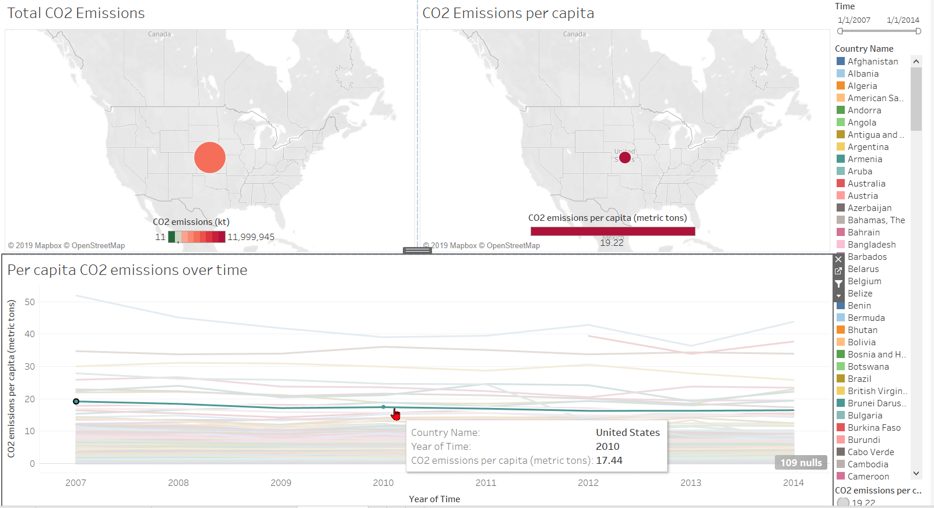

1. Highlight: When the user hovers over a country on either of the maps, the corresponding line in the line chart is highlighted.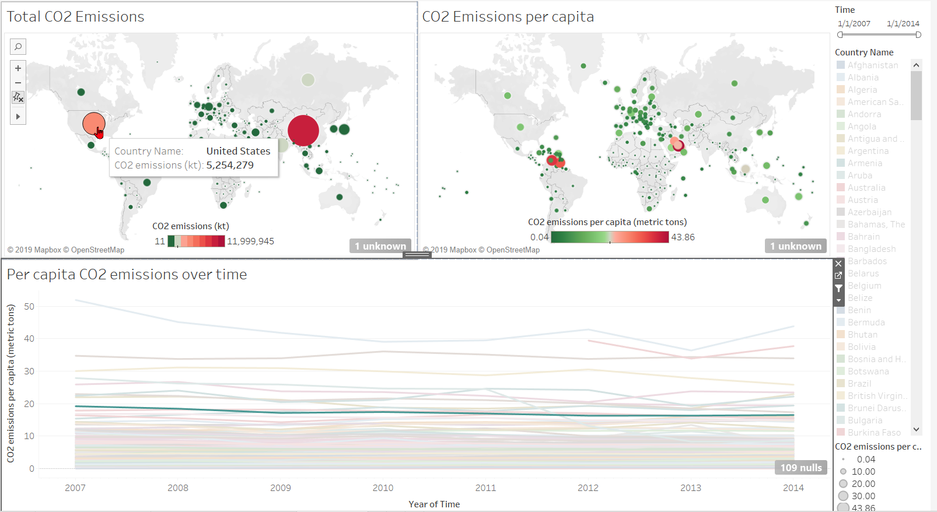
2. URL: When the user clicks on a country in either map, a menu pops up with a link to the Wikipedia page for that country.

