Tableau Dashboards

Use Tableau to connect to the *Sample – Coffee Chain.xlsx* file.

Create the following visualizations:

# Geographic Sales and Profit

* Sales for each state are indicated by the size of the dot.
* Profit is indicated by the intensity of the dot’s color.

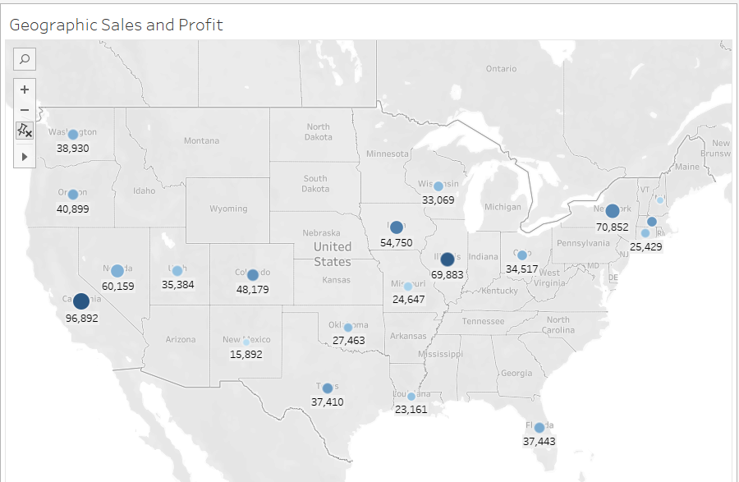

# Sales by Product Type

* Sales for each of the 4 product types as a percent of the total sales.
* Percent values have 0 decimal places.
* Dollar values have 0 decimal places and a dollar sign.
* The chart takes up the entire view.

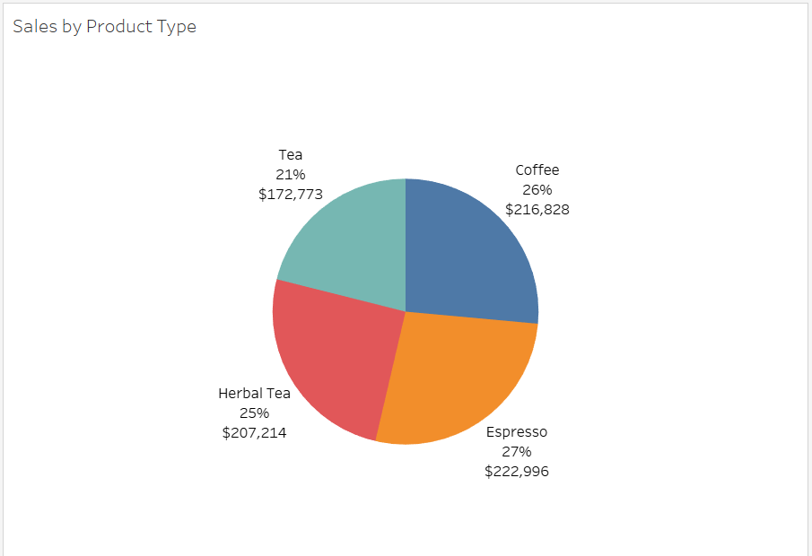

# Sales over Time

* Sales is on the vertical axis.
* Quarter and year are on the horizontal axis.
* There is one line for each state’s Sales and each line is a different color.

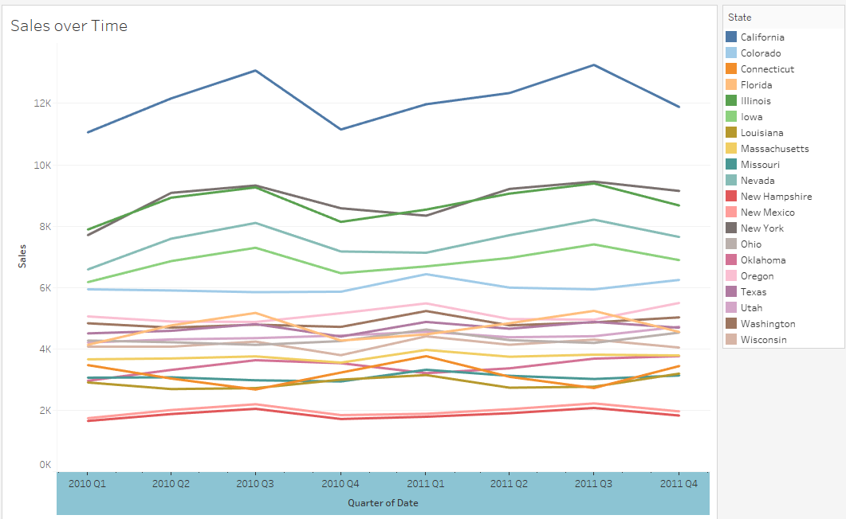

# Dashboard

Now create the following dashboard. Set the *Size* to *PowerPoint (1600x 900)*:

* Put the map in the top left quadrant.
* Put the pie chart in the top right quadrant.
* Put the time line across the bottom half.
* Make the State a filter for all 3 charts. Note that in the *State* filter box (bottom right) all state check boxes have been turned off except Iowa, Wisconsin, Missouri, and Illinois. So there are only 4 dots on the map, 4 lines on the line chart, and the pie chart totals are just the totals for those 4 states.

