Pie Charts and Tree Maps

Pie Chart
Create the following pie chart. Connect to the Superstore Sales Training.xlsx file and select the Orders table. The file has the following features:
- There is one pie segment for each Region.
- The Profit for each Region is displayed.
- Each pie segment is labeled with the name of the Region.
- The Tableau Classic 10 color palette has been assigned.
- Region is above the Profit in the label.
- Each pie segment is labeled with the amount of the Profit.
- The Profit is formatted with a dollar sign, commas, and zero decimal places.
- The font for the labels is 12-point, bold, and black.
- The worksheet has been renamed Profit by Region.
Your chart should look like this:
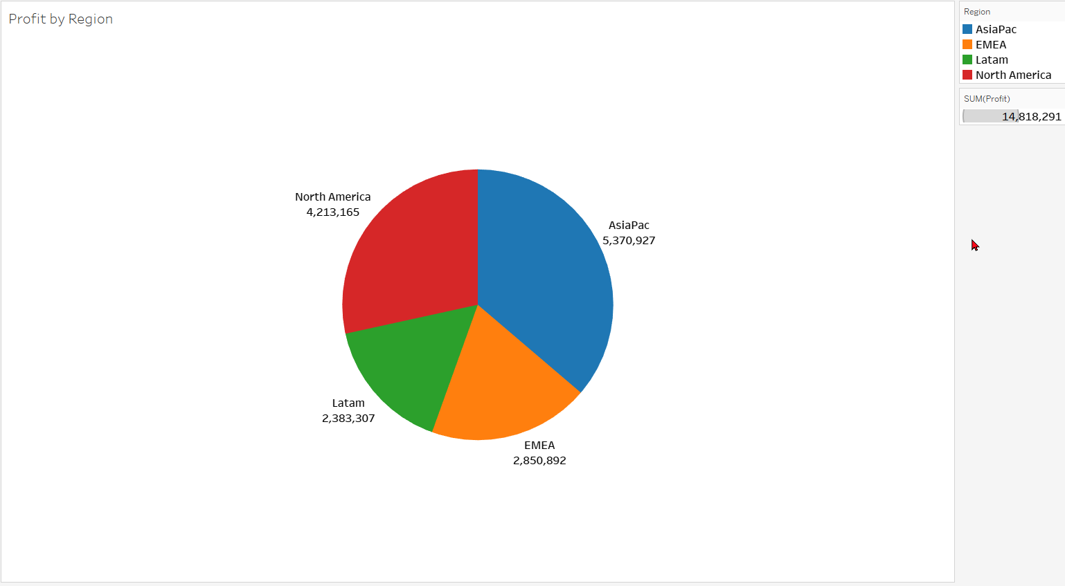

Tree Map
Create the following tree map. Again use the Orders table from the Superstore Sales Training.xlsx file.
- Show the sum of the Sales.
- Divide the data by Region.
- Subdivide each Region by Category.
- If the name of the Region appears in each rectangle, remove it. We can determine the Region from the legend.
- Display the name of each Category in each rectangle.
- Display the sum of the Sales below the Category in each rectangle.
- Format the Sales with a dollar sign, commas, and zero decimal places.
- The color palette is Tableau Classic 10.
- The worksheet title has been changed to Sales by Region and Category.
Your chart should look like this:
