Tableau Highlight Tables and Heat Maps

Highlight Table (one measure)
Use the file LondonCO2EmissionsByBorough.xlsx. Then create a table that meets the following criteria.
- Create one row for each borough.
- Create one column for each year. You may have to change it to a discrete measure.
- Display the CO₂ in the center of the table.
- Since the different boroughs have greatly different populations and therefore greatly different amounts of CO2 emissions, instead of looking at absolute numbers, we will look at relative numbers. That is, we will look at each borough's numbers relative to the other years for that same borough. Convert each number in the table to its percent of the row total. This will allow us to see declines in the relative values better.
- Choose a single-color scale.
- Create 4 color steps.
- The darker shades should be associated with higher values, and lighter shades should be associated with lower values. Below you can easily see how the CO2 emissions have declined over the 10 years displayed.
- To make it easier to see individual cells in the table, change the cell borders to a light gray color.
- Change the worksheet title to London CO2 Emissions, 2005-2014.
Your visualization should be similar to the one below. Note how all of the dark red is on the left and the light red is on the right.
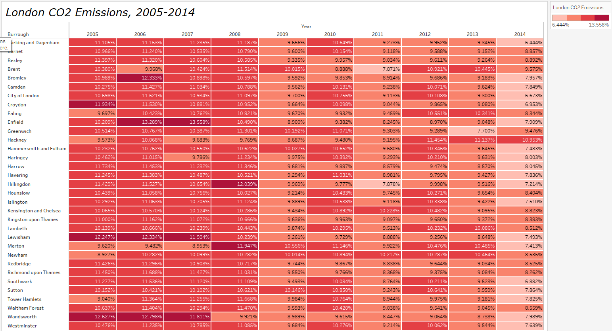

Heat Map (2 measures)
Connect to the Sample – Coffee Chain.xlsx file. Then create a heat map that meets the following criteria.
- Create one row for each state.
- Create one column for each coffee type (Product Type).
- Sales is represented by size.
- Sales is also represented by a text value. You may have to widen your columns if the colored square and the text overlap.
- Profit is represented by color.
- The profit colors are a diverging color palette. Here a red-green is used. You can pick your own colors.
- The profit colors are a stepped color with 4 steps.
- Profit is also represented by a text value. You may have to make the rows taller if you don't see two numbers in each cell.
- The worksheet name is Coffee Sales and Profit by State.
Your visualization should be similar to the one below.
