Tableau Maps: Earthquakes!
Create the following map:
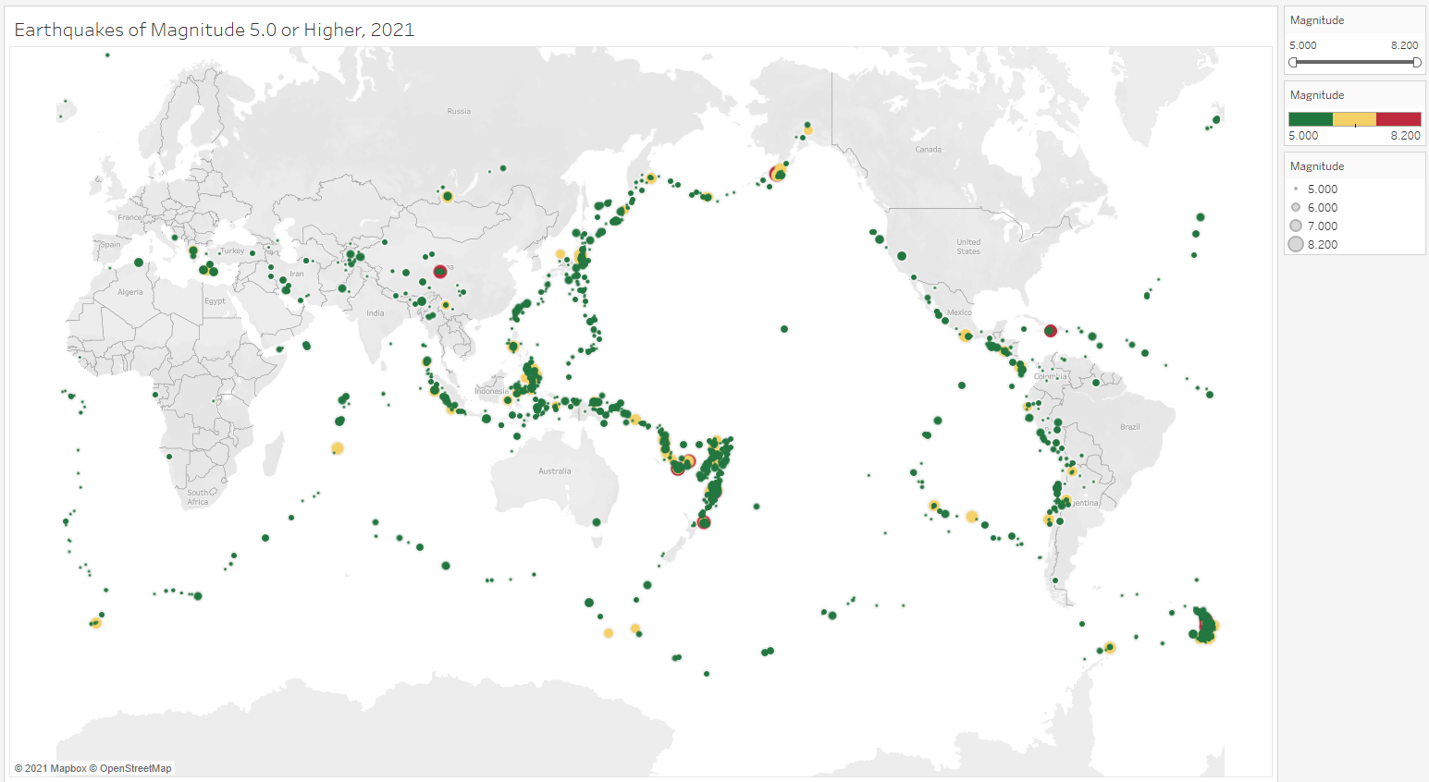
The map has the following features:
- It is a symbol map (not a choropleth map).
- Displays all magnitudes by size.
- Displays all magnitudes by color as well.
- Uses a 3-color scale.
- The size legend has been modified to show sizes "By range". This gives a greater variation in the sizes of the dots.
- A magnitude filter has been added and its slider is visible on the right side of the chart.
- The title of the chart is Earthquakes of Magnitude 5.0 or Higher, 2021.
The chart looks like this when a filter has been applied to show only those quakes with a magnitude of 6.500 or larger:
