Tableau Data Visualization: Calculated Fields
Create the following visualization that shows the rate of cell phone use by country for North America and the European Union. The data file for the map is World-Bank-Indicators.xlsx.
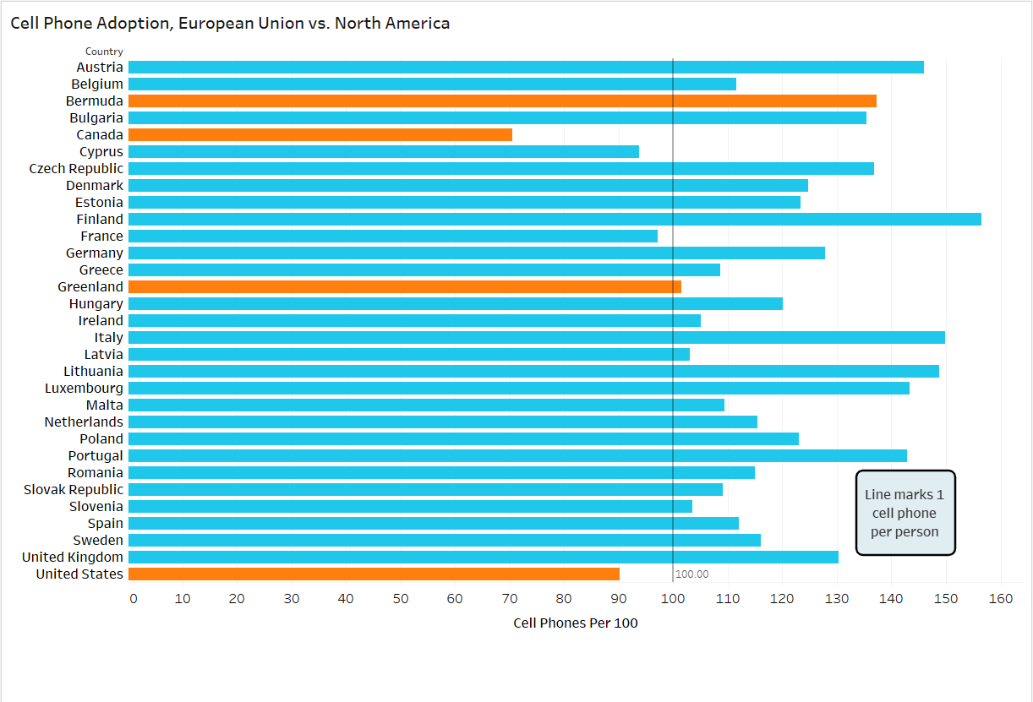
- Select the Country Data worksheet and the Regions and Subregions worksheet for your data.
- Select/Filter data for just the year 2010 (it has data for 2000-2010).
- Select/Filter data for just the Sub-regions of North America and the European Union.
- Create a calculated field called Cell Phones per 100. To compute it, take the total number of cell phones for the country (field: Business: Mobile phone subscribers) and divide it by the population for that country (Population:Total(count)). This will give you the number of cell phones per person (which is kind of a meaningless number). Multiply it by 100 to get the number of cell phones per 100 residents, a number that makes more sense.
- Create a chart with the Country name (Country/Region field) on the y-axis.
- Put the Cell Phones per 100 on the x-axis.
- Use the Subregion field to determine the color of each bar.
- The bar color for the North America Subregion should be a shade of orange.
- The bar color for the European Union Subregion should be a shade of light blue.
- Add a Reference Line at the 100 mark on the x-axis (use Help/Google for this). This is the point at which everybody in the country has exactly one cell phone (on average).
- Format the reference line that you just created. Make it a heavy black dotted line.
- Add a box annotation with the text Line marks 1 cell phone per person. The format is up to you.
- Change the title to Cell Phone Adoption, European Union vs. North America

