CSCI-IS Data Visualization
This assignment will begin to use Tableau. Create following chart. Instructions are below the chart.
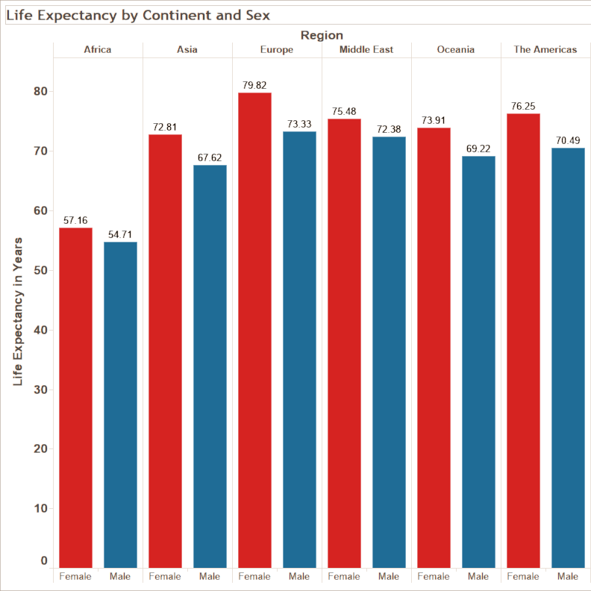
- Connect to the World Indicators.xlsx file.
- Use the data to create the following chart. It plots the life expectancy for males and females, grouped by continent and has the following features:
  - The bars are vertical.
  - The continents are across the top of the chart.
  - The sexes are across the bottom.
  - The x-axis labels have been changed (given an "alias") of "Female" and "Male".
  - The female bars have been changed to red, and the male bars have been changed to blue.
  - The number that each bar represents is at the top of the bar.
  - The title has been changed to Life Expectancy by Continent and Sex.
  - A title has been added to the y-axis.
  - The font style for the title and numbers on the y-axis has been set to 10-point bold.
- Save your tbwx file (not tbw) and put it in the drop box.

